**Safe early bacteria**

**Bar plot**

otutable <- import_biom(BIOMfilename = 'HMCStress_json.biom', treefilename = 'rep_set HMCStress.tre', parseFunction = parse_taxonomy_greengenes)

mapping <- import_qiime_sample_data(mapfilename = "mapfinal_corrected.txt")

phylo <- merge_phyloseq(otutable, mapping)

phylo = prune_taxa(taxa_sums(phylo) > 0, phylo)

phylo

top10 <- names(sort(taxa_sums(phylo), TRUE)[1:20])

ent10 <- prune_species(top10, phylo)

p=plot_bar(ent10, "treatment", fill="Family", facet_grid = ~day)

p + geom_bar(aes(color=Family, fill= Family), stat="identity", positon="stack")

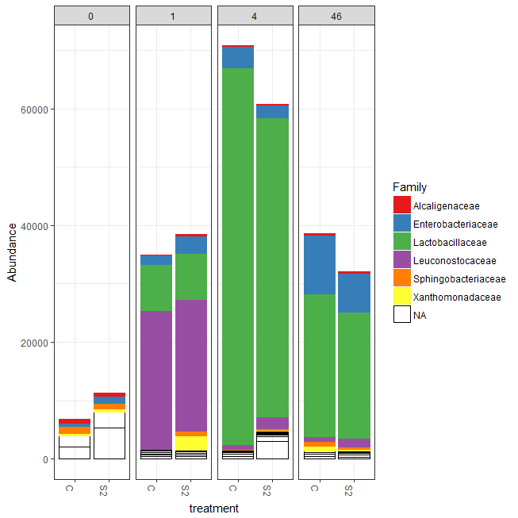

**Richness**

p <- plot_richness(phylo, x = "Treatment", measures = c("Observed", "Chao1", "Shanon", "Simpson", "InvSimpson"))

p + geom_point(size=5, alpha=0.7)

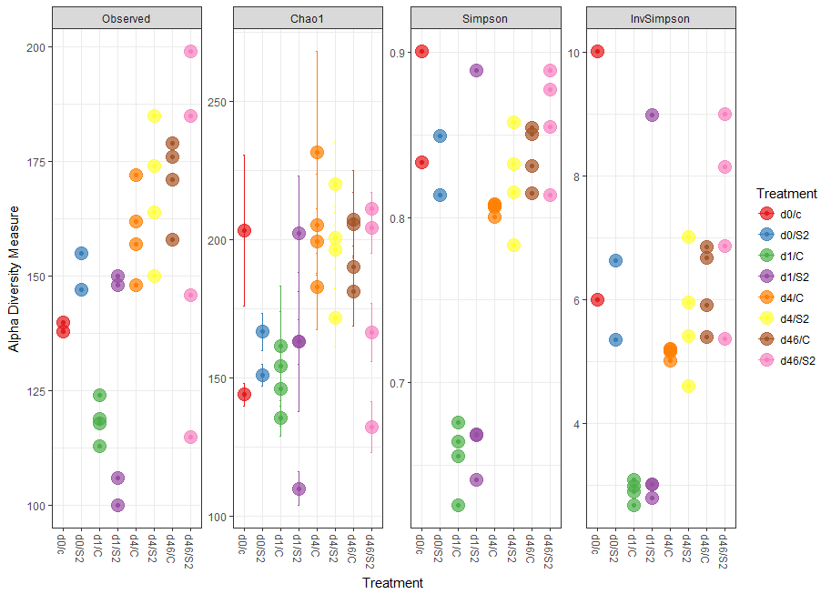

alpha.diversity <- estimate_richness(phylo, measures = c("Observed", "Chao1", "Shannon", "Simpson", "InvSimpson"))

write.table(alpha.diversity, "safeearly.txt")

|  |  |  |  |  |  |  |
| --- | --- | --- | --- | --- | --- | --- |
| sample | Observed | Chao1 | se.chao1 | Shannon | Simpson | InvSimpson |
| X320 | 147 | 151 | 3.890270855 | 2.952383412 | 0.813430801 | 5.359941552 |
| X330 | 148 | 163 | 7.949309786 | 2.915130982 | 0.888731817 | 8.987295144 |
| X352 | 174 | 200.4642857 | 11.14920196 | 2.667040666 | 0.857637316 | 7.02431262 |
| X318 | 138 | 144 | 4.161321572 | 3.01045271 | 0.833286013 | 5.998296962 |
| X323 | 113 | 154.3333333 | 19.80382786 | 2.127972296 | 0.664422896 | 2.97994109 |
| X329 | 100 | 110.0588235 | 6.176513458 | 1.935001798 | 0.641495006 | 2.789361422 |
| X328 | 150 | 202.1052632 | 20.83858039 | 2.135361849 | 0.668889912 | 3.020143558 |
| X375 | 199 | 211.0833333 | 6.014018352 | 2.819484509 | 0.813711857 | 5.368028175 |
| X317 | 140 | 203.0769231 | 27.26380356 | 2.966666779 | 0.900123234 | 10.01233858 |
| X374 | 179 | 205.64 | 11.52152016 | 2.858508038 | 0.830953674 | 5.915538211 |
| X371 | 176 | 190.1304348 | 7.374706527 | 2.956776958 | 0.850380008 | 6.683598818 |
| X377 | 146 | 166.3125 | 10.51204524 | 2.985577221 | 0.87734747 | 8.153113492 |
| X319 | 155 | 166.6666667 | 6.785103219 | 3.133975296 | 0.84913587 | 6.628480869 |
| X372 | 171 | 207.25 | 17.82817568 | 2.671977106 | 0.814823201 | 5.40024455 |
| X349 | 172 | 199.4444444 | 11.55809779 | 2.435086849 | 0.808040828 | 5.2094411 |
| X378 | 185 | 204.0769231 | 8.916127582 | 3.138497582 | 0.888902794 | 9.00112644 |
| X376 | 115 | 132.25 | 9.296960235 | 2.810395603 | 0.854531543 | 6.87434251 |
| X354 | 150 | 171.75 | 10.46277018 | 2.481765071 | 0.815288487 | 5.413847693 |
| X353 | 185 | 220.15 | 15.07971388 | 2.624316327 | 0.832158342 | 5.957996427 |
| X325 | 119 | 146.0666667 | 13.31496793 | 1.916944083 | 0.625856907 | 2.672774184 |
| X350 | 148 | 183 | 15.71355712 | 2.38832888 | 0.800446023 | 5.011175506 |
| X347 | 162 | 205.3333333 | 18.28720523 | 2.414834812 | 0.806467807 | 5.167099002 |
| X348 | 157 | 231.375 | 36.4656843 | 2.410213051 | 0.807174196 | 5.18602791 |
| X373 | 158 | 181.0769231 | 12.23289594 | 2.927951999 | 0.854114881 | 6.854708744 |
| X351 | 164 | 196.2173913 | 13.5880692 | 2.309240682 | 0.782992511 | 4.608135903 |
| X324 | 118 | 161.5 | 21.78682161 | 2.158732629 | 0.676234972 | 3.08865972 |
| X326 | 124 | 135.5 | 6.425526306 | 2.127971769 | 0.655660281 | 2.904108776 |
| X327 | 106 | 163 | 25.09070488 | 2.104950809 | 0.668307083 | 3.014836763 |
|  |  |  |  |  |  |  |
|  |  |  |  |  |  |  |

**CoA**

library("plyr"); packageVersion("plyr")

theme_set(theme_bw())

wh0 = genefilter_sample(phylo, filterfun_sample(function(x) x > 5), A=0.5*nsamples(phylo))

GP1 = prune_taxa(wh0, phylo)

GP1 = transform_sample_counts(GP1, function(x) 1E6 * x/sum(x))

ord_meths = c("PCoA")

plist = llply(as.list(ord_meths), function(i, physeq, dist){ordi = ordinate(physeq, method=i, distance=dist) plot_ordination(physeq, ordi, "samples", color="Treatment"}, GP1, dist)

dist = "bray"

ord_meths = c("DCA", "CCA", "RDA", "DPCoA", "NMDS", "MDS", "PCoA")

plist = llply(as.list(ord_meths), function(i, phylo, dist){ordi = ordinate(phylo, method=i, distance=dist) plot_ordination(phylo, ordi, "samples", color="Treatment")}, GP1, dist)

names(plist) <- ord_meths

pdataframe = ldply(plist, function(x){df = x$data[, 1:2] colnames(df) = c("Axis_1", "Axis_2") return(cbind(df, x$data))})

names(pdataframe)[1] = "method"

p = ggplot(pdataframe, aes(Axis_1, Axis_2, color=Treatment, fill=Treatment))

p = p + geom_point(size=4) + geom_polygon()

p = p + facet_wrap(~method, scales="free")

p = p + scale_fill_brewer(type="qual", palette="Set1")

p = p + scale_colour_brewer(type="qual", palette="Set1")

p

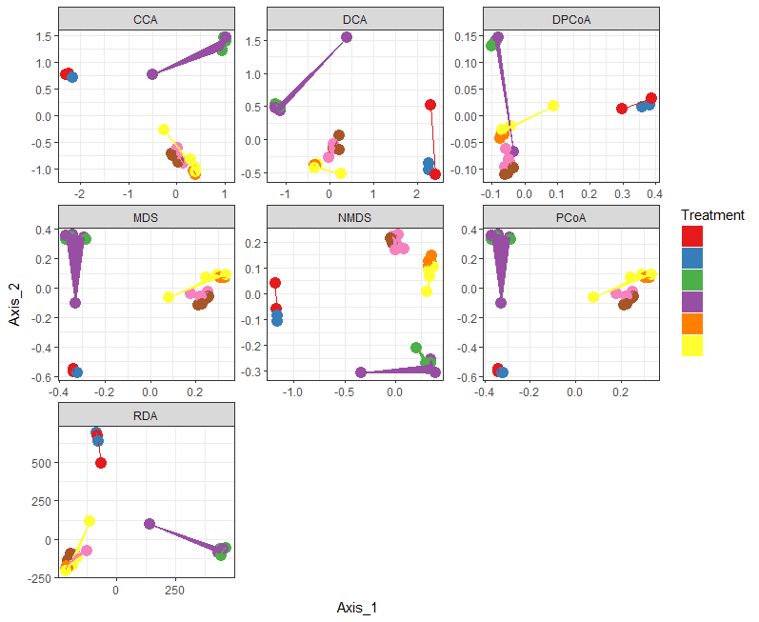

p= plist[[6]]

p = plist[[6]] + scale_colour_brewer(type="qual", palette="Set1")

p = p + scale_fill_brewer(type="qual", palette="Set1")

p = p + geom_point(size=5) + geom_polygon(aes(fill=Treatment))

p

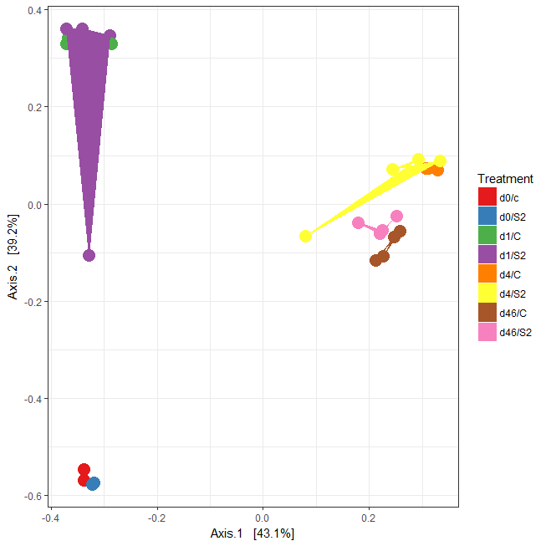

**Differential abundance**

biocLite("DESeq2")

library("DESeq2")

kostic = phylo

kostic = subset_samples(kostic, mapping != "Treatment")

kostic

head(sample_data(kostic)$Treatment, 8)

kostic = subset_samples(kostic, mapping != "Treatment")

diagdds = phyloseq_to_deseq2(kostic, ~ Treatment)

diagdds = DESeq(diagdds, test="Wald", fitType="parametric")

res = results(diagdds, cooksCutoff = FALSE)

alpha = 0.01

sigtab = res[which(res$padj < alpha), ]

sigtab = cbind(as(sigtab, "data.frame"), as(tax_table(kostic)[rownames(sigtab), ], "matrix"))

head(sigtab)

dim(sigtab)

library("ggplot2")

theme_set(theme_bw())

scale_fill_discrete <- function(palname = "Set1", ...) {

scale_fill_brewer(palette = palname, ...)

}

# Phylum order

x = tapply(sigtab$log2FoldChange, sigtab$Phylum, function(x) max(x))

x = sort(x, TRUE)

sigtab$Phylum = factor(as.character(sigtab$Phylum), levels=names(x))

# Family order

x = tapply(sigtab$log2FoldChange, sigtab$Family, function(x) max(x))

x = sort(x, TRUE)

sigtab$Family = factor(as.character(sigtab$Family), levels=names(x))

p = ggplot(sigtab, aes(x=Family, y=log2FoldChange, color=Phylum)) + geom_point(size=6) +

theme(axis.text.x = element_text(angle = -90, hjust = 0, vjust=0.5))

p

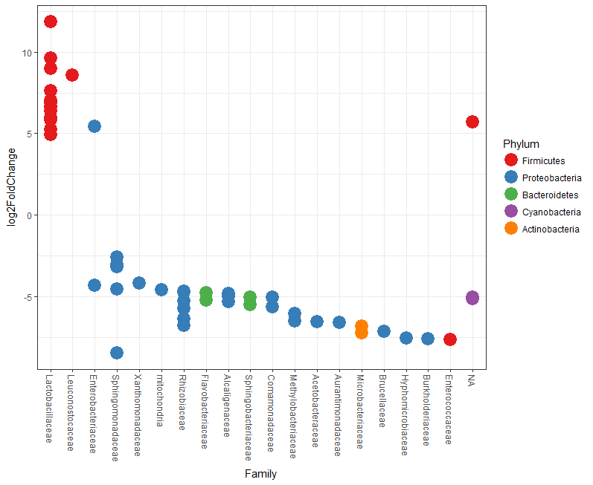

|  |  |  |  |  |  |  |  |  |  |  |  |  |  |  |
| --- | --- | --- | --- | --- | --- | --- | --- | --- | --- | --- | --- | --- | --- | --- |
| OUT | baseMean | log2FoldChange | lfcSE | stat | pvalue | padj | Kingdom | Phylum | Class | Order | Family | Genus | Species | Rank1 |
| 1110317 | 2515.618859 | 11.85312405 | 1.629218207 | 7.2753447 | 3.46E-13 | 6.57E-11 | Bacteria | Firmicutes | Bacilli | Lactobacillales | Lactobacillaceae | Lactobacillus | brevis | NA |
| 4429559 | 80.08248652 | 4.919340913 | 1.604123358 | 3.06668492 | 0.002164469 | 0.007759416 | Bacteria | Firmicutes | Bacilli | Lactobacillales | Lactobacillaceae | Lactobacillus | brevis | NA |
| New.CleanUp.ReferenceOTU3108 | 2.624670495 | -4.733104253 | 1.393372941 | -3.396868213 | 0.000681618 | 0.003083509 | Bacteria | Proteobacteria | Alphaproteobacteria | Rhizobiales | Rhizobiaceae | Agrobacterium | NA | NA |
| 633100 | 29.90606633 | 5.976464873 | 1.740081853 | 3.434588357 | 0.000593455 | 0.002750155 | Bacteria | Firmicutes | Bacilli | Lactobacillales | Lactobacillaceae | Lactobacillus | brevis | NA |
| New.ReferenceOTU80 | 121.9383682 | 6.599938867 | 1.713668587 | 3.85135079 | 0.000117468 | 0.000797105 | Bacteria | Firmicutes | Bacilli | Lactobacillales | Lactobacillaceae | Lactobacillus | NA | NA |
| 339358 | 3949.230461 | 8.588912924 | 1.59988311 | 5.368462778 | 7.94E-08 | 3.02E-06 | Bacteria | Firmicutes | Bacilli | Lactobacillales | Leuconostocaceae | NA | NA | NA |
| 963779 | 37.69445139 | -6.384047713 | 1.619828523 | -3.941187368 | 8.11E-05 | 0.000570558 | Bacteria | Proteobacteria | Alphaproteobacteria | Rhizobiales | Rhizobiaceae | Agrobacterium | NA | NA |
| 4358818 | 235.6604751 | 7.596070003 | 1.664209182 | 4.564372125 | 5.01E-06 | 7.46E-05 | Bacteria | Firmicutes | Bacilli | Lactobacillales | Lactobacillaceae | Lactobacillus | NA | NA |
| 1053775 | 12.74501932 | -7.557713843 | 2.295429274 | -3.292505646 | 0.000992989 | 0.004031051 | Bacteria | Proteobacteria | Alphaproteobacteria | Rhizobiales | Hyphomicrobiaceae | Devosia | NA | NA |
| 1104627 | 3.369048548 | -6.783428185 | 2.189818487 | -3.097712539 | 0.001950205 | 0.007193765 | Bacteria | Proteobacteria | Alphaproteobacteria | Rhizobiales | Rhizobiaceae | Rhizobium | leguminosarum | NA |
| 868791 | 51.41225467 | -4.533522057 | 1.051109773 | -4.313081441 | 1.61E-05 | 0.000169939 | Bacteria | Proteobacteria | Alphaproteobacteria | Sphingomonadales | Sphingomonadaceae | Sphingomonas | NA | NA |
| 992510 | 43.62960249 | -3.051161761 | 0.60110342 | -5.075934787 | 3.86E-07 | 9.16E-06 | Bacteria | Proteobacteria | Alphaproteobacteria | Sphingomonadales | Sphingomonadaceae | Sphingomonas | yabuuchiae | NA |
| New.ReferenceOTU54 | 9.837168542 | 5.268368916 | 1.614533343 | 3.263090811 | 0.001102042 | 0.00436225 | Bacteria | Firmicutes | Bacilli | Lactobacillales | Lactobacillaceae | Lactobacillus | NA | NA |
| 1918929 | 40.57202158 | -4.610921829 | 1.221310261 | -3.775389411 | 0.000159758 | 0.0010118 | Bacteria | Proteobacteria | Alphaproteobacteria | Rickettsiales | mitochondria | NA | NA | NA |
| New.CleanUp.ReferenceOTU16762 | 24.97236636 | -5.661276162 | 1.370253009 | -4.131555359 | 3.60E-05 | 0.000297653 | Bacteria | Proteobacteria | Betaproteobacteria | Burkholderiales | Comamonadaceae | Delftia | NA | NA |
| 656774 | 38.55525579 | -5.06832961 | 1.111337194 | -4.560568687 | 5.10E-06 | 7.46E-05 | Bacteria | Proteobacteria | Betaproteobacteria | Burkholderiales | Comamonadaceae | Comamonas | NA | NA |
| 819037 | 5.456445722 | -5.049668461 | 1.5631333 | -3.230478463 | 0.001235832 | 0.004792002 | Bacteria | Proteobacteria | Betaproteobacteria | Burkholderiales | Comamonadaceae | NA | NA | NA |
| 565246 | 74.57257281 | -5.350021461 | 1.145562247 | -4.670214541 | 3.01E-06 | 5.51E-05 | Bacteria | Proteobacteria | Betaproteobacteria | Burkholderiales | Alcaligenaceae | Achromobacter | NA | NA |
| 653007 | 24.33583889 | -4.996809149 | 1.491930778 | -3.349223182 | 0.000810385 | 0.003499389 | Bacteria | Proteobacteria | Betaproteobacteria | Burkholderiales | Alcaligenaceae | Achromobacter | NA | NA |
| 661229 | 109.9430703 | -4.841090104 | 0.879203255 | -5.506224049 | 3.67E-08 | 1.74E-06 | Bacteria | Proteobacteria | Betaproteobacteria | Burkholderiales | Alcaligenaceae | Achromobacter | NA | NA |
| 814176 | 54.84461045 | -7.620270947 | 1.695943398 | -4.49323424 | 7.01E-06 | 8.33E-05 | Bacteria | Proteobacteria | Betaproteobacteria | Burkholderiales | Burkholderiaceae | Burkholderia | NA | NA |
| 816760 | 21.45252333 | -4.677179819 | 1.101397449 | -4.246586756 | 2.17E-05 | 0.000187454 | Bacteria | Proteobacteria | Alphaproteobacteria | Rhizobiales | Rhizobiaceae | Agrobacterium | NA | NA |
| 969805 | 20.62768382 | -5.744809236 | 1.572189138 | -3.654019163 | 0.000258167 | 0.001492146 | Bacteria | Proteobacteria | Alphaproteobacteria | Rhizobiales | Rhizobiaceae | NA | NA | NA |
| 1072513 | 2.733887999 | -6.584206051 | 2.000470764 | -3.291328307 | 0.000997155 | 0.004031051 | Bacteria | Proteobacteria | Alphaproteobacteria | Rhizobiales | Aurantimonadaceae | NA | NA | NA |
| 1108960 | 21.21981041 | -2.574330647 | 0.856907252 | -3.00421153 | 0.002662701 | 0.009368764 | Bacteria | Proteobacteria | Alphaproteobacteria | Sphingomonadales | Sphingomonadaceae | Sphingomonas | NA | NA |
| New.ReferenceOTU58 | 39.38705526 | 5.834500344 | 1.688116741 | 3.45621852 | 0.000547811 | 0.002713894 | Bacteria | Firmicutes | Bacilli | Lactobacillales | Lactobacillaceae | Lactobacillus | NA | NA |
| 102348 | 7.285334595 | -6.558179574 | 1.860536639 | -3.524886013 | 0.000423665 | 0.00236754 | Bacteria | Proteobacteria | Alphaproteobacteria | Rhodospirillales | Acetobacteraceae | NA | NA | NA |
| 250206 | 16.02809861 | -5.282046564 | 1.332966251 | -3.962625879 | 7.41E-05 | 0.000541718 | Bacteria | Proteobacteria | Alphaproteobacteria | Rhizobiales | Rhizobiaceae | Agrobacterium | NA | NA |
| 850731 | 12.30793299 | -5.752276844 | 1.650694504 | -3.484761614 | 0.000492576 | 0.002633185 | Bacteria | Proteobacteria | Alphaproteobacteria | Rhizobiales | Rhizobiaceae | NA | NA | NA |
| 785526 | 6.572655214 | -6.038779817 | 1.421655848 | -4.247708633 | 2.16E-05 | 0.000187454 | Bacteria | Proteobacteria | Alphaproteobacteria | Rhizobiales | Methylobacteriaceae | NA | NA | NA |
| 175931 | 3.401255934 | -6.504078037 | 1.870190622 | -3.477762084 | 0.000505618 | 0.002633185 | Bacteria | Proteobacteria | Alphaproteobacteria | Rhizobiales | Methylobacteriaceae | Methylobacterium | NA | NA |
| 153978 | 42.80873222 | -5.056643521 | 1.085569649 | -4.658055358 | 3.19E-06 | 5.51E-05 | Bacteria | Cyanobacteria | Chloroplast | Streptophyta | NA | NA | NA | NA |
| 616310 | 1013.090516 | -5.167841277 | 0.999842676 | -5.168654431 | 2.36E-07 | 6.40E-06 | Bacteria | Cyanobacteria | Chloroplast | Streptophyta | NA | NA | NA | NA |
| New.ReferenceOTU22 | 77.14825367 | -7.136526652 | 1.666194341 | -4.283129811 | 1.84E-05 | 0.000184283 | Bacteria | Proteobacteria | Alphaproteobacteria | Rhizobiales | Brucellaceae | Ochrobactrum | NA | NA |
| 891031 | 195.1160452 | -5.046190248 | 1.037184211 | -4.8652787 | 1.14E-06 | 2.41E-05 | Bacteria | Bacteroidetes | Sphingobacteriia | Sphingobacteriales | Sphingobacteriaceae | Sphingobacterium | multivorum | NA |
| 682737 | 4.547792263 | -5.517167194 | 1.215199909 | -4.540131342 | 5.62E-06 | 7.63E-05 | Bacteria | Bacteroidetes | Sphingobacteriia | Sphingobacteriales | Sphingobacteriaceae | Sphingobacterium | multivorum | NA |
| 1119860 | 8.518432602 | -4.791968664 | 1.486663558 | -3.223304048 | 0.00126721 | 0.004815397 | Bacteria | Bacteroidetes | Flavobacteriia | Flavobacteriales | Flavobacteriaceae | NA | NA | NA |
| 1122504 | 18.57328424 | -5.229892438 | 1.417877582 | -3.688535953 | 0.000225548 | 0.001382392 | Bacteria | Bacteroidetes | Flavobacteriia | Flavobacteriales | Flavobacteriaceae | NA | NA | NA |
| 1045797 | 5.26061422 | -6.853295218 | 1.583773933 | -4.327192838 | 1.51E-05 | 0.000168789 | Bacteria | Actinobacteria | Actinobacteria | Actinomycetales | Microbacteriaceae | Microbacterium | NA | NA |
| 1108350 | 82.59656495 | -7.257002695 | 1.403112786 | -5.172073669 | 2.32E-07 | 6.40E-06 | Bacteria | Actinobacteria | Actinobacteria | Actinomycetales | Microbacteriaceae | Microbacterium | chocolatum | NA |
| 1111582 | 3.68119942 | -7.642227188 | 1.855446139 | -4.118808424 | 3.81E-05 | 0.000301496 | Bacteria | Firmicutes | Bacilli | Lactobacillales | Enterococcaceae | Enterococcus | casseliflavus | NA |
| New.ReferenceOTU27 | 196.3918415 | 5.684482988 | 1.713890169 | 3.31671369 | 0.000910829 | 0.003845723 | Bacteria | Firmicutes | Bacilli | Lactobacillales | NA | NA | NA | NA |
| New.ReferenceOTU30 | 5.159705633 | -8.474471078 | 2.319846032 | -3.653031692 | 0.000259162 | 0.001492146 | Bacteria | Proteobacteria | Alphaproteobacteria | Sphingomonadales | Sphingomonadaceae | Sphingomonas | NA | NA |
| 1107385 | 34.2720547 | 7.025384511 | 1.560806698 | 4.501124015 | 6.76E-06 | 8.33E-05 | Bacteria | Firmicutes | Bacilli | Lactobacillales | Lactobacillaceae | Lactobacillus | NA | NA |
| New.ReferenceOTU21 | 60.05258339 | 5.423089246 | 1.576370267 | 3.440238222 | 0.000581202 | 0.002750155 | Bacteria | Proteobacteria | Gammaproteobacteria | Enterobacteriales | Enterobacteriaceae | NA | NA | NA |
| 760901 | 1908.105729 | 9.609077594 | 1.626462044 | 5.907963011 | 3.46E-09 | 3.29E-07 | Bacteria | Firmicutes | Bacilli | Lactobacillales | Lactobacillaceae | NA | NA | NA |
| 613189 | 394.9711126 | 6.910839712 | 1.622601902 | 4.259109831 | 2.05E-05 | 0.000187454 | Bacteria | Firmicutes | Bacilli | Lactobacillales | Lactobacillaceae | NA | NA | NA |
| 160548 | 228.4681918 | 6.379517115 | 1.680730079 | 3.795682123 | 0.000147238 | 0.000964663 | Bacteria | Firmicutes | Bacilli | Lactobacillales | Lactobacillaceae | Lactobacillus | brevis | NA |
| New.ReferenceOTU40 | 8.790593769 | -3.165033487 | 1.02266234 | -3.094895905 | 0.00196882 | 0.007193765 | Bacteria | Proteobacteria | Alphaproteobacteria | Sphingomonadales | Sphingomonadaceae | Sphingomonas | NA | NA |
| 781576 | 268.5430903 | 6.647510909 | 1.627986112 | 4.083272493 | 4.44E-05 | 0.000337485 | Bacteria | Firmicutes | Bacilli | Lactobacillales | Lactobacillaceae | NA | NA | NA |
| 275097 | 2.548266913 | -4.346678449 | 1.25928552 | -3.45170208 | 0.000557062 | 0.002713894 | Bacteria | Proteobacteria | Gammaproteobacteria | Enterobacteriales | Enterobacteriaceae | NA | NA | NA |
| New.ReferenceOTU7 | 127.9785672 | 4.945324216 | 1.42352818 | 3.473991092 | 0.000512778 | 0.002633185 | Bacteria | Firmicutes | Bacilli | Lactobacillales | Lactobacillaceae | Lactobacillus | NA | NA |
| 815480 | 60.89495397 | -4.208970801 | 1.249470577 | -3.368603373 | 0.000755501 | 0.003338258 | Bacteria | Proteobacteria | Gammaproteobacteria | Xanthomonadales | Xanthomonadaceae | Stenotrophomonas | NA | NA |
| 949863 | 140.7814758 | 8.978580814 | 1.620556522 | 5.540430519 | 3.02E-08 | 1.74E-06 | Bacteria | Firmicutes | Bacilli | Lactobacillales | Lactobacillaceae | Lactobacillus | NA | NA |

**Safe early post bacteria**

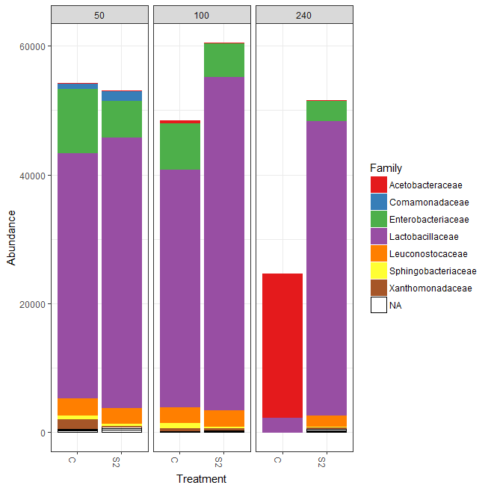

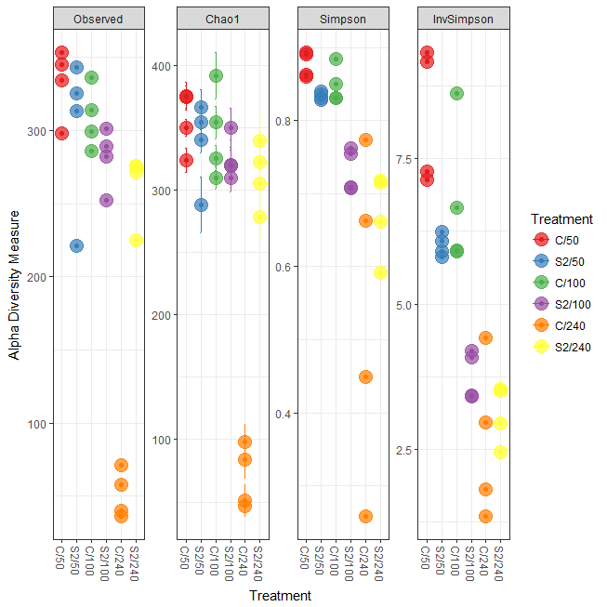

|  |  |  |  |  |  |  |
| --- | --- | --- | --- | --- | --- | --- |
| sample | Observed | Chao1 | se.chao1 | Shannon | Simpson | InvSimpson |
| 777 | 286 | 310.1090909 | 8.948453108 | 2.829224058 | 0.830903711 | 5.913790351 |
| 770 | 345 | 375.625 | 11.40400141 | 3.314251075 | 0.892660592 | 9.31624294 |
| 772 | 325 | 366.5909091 | 13.9761203 | 2.861537666 | 0.830774746 | 5.909283477 |
| 775 | 336 | 392 | 18.43365324 | 3.297583715 | 0.884075084 | 8.626273214 |
| 776 | 299 | 325.8571429 | 10.24754862 | 3.038494896 | 0.849651939 | 6.651233104 |
| 780 | 301 | 350.1333333 | 15.74465951 | 2.327069553 | 0.70823165 | 3.427376553 |
| 781 | 289 | 320.3333333 | 11.89137643 | 2.577252688 | 0.761894695 | 4.19982242 |
| 788 | 271 | 305.4375 | 11.91026508 | 2.288623839 | 0.661652894 | 2.95554471 |
| 790 | 276 | 322.6666667 | 16.40246825 | 2.436010883 | 0.714954604 | 3.508213122 |
| 767 | 353 | 375.0243902 | 8.931281353 | 3.301191318 | 0.890949452 | 9.170059384 |
| 768 | 334 | 350.125 | 6.741717475 | 3.057384504 | 0.859734499 | 7.129336832 |
| 774 | 313 | 340.8409091 | 10.40835412 | 2.908369627 | 0.835569781 | 6.081607174 |
| 789 | 275 | 340.0294118 | 21.02452441 | 2.342944133 | 0.716971925 | 3.533218392 |
| 778 | 314 | 354.6785714 | 12.98041494 | 2.823463614 | 0.8308495 | 5.911895022 |
| 782 | 282 | 309.972973 | 10.86767671 | 2.614039527 | 0.754689474 | 4.076465929 |
| 773 | 343 | 354.4423077 | 5.414533415 | 2.978128761 | 0.839926437 | 6.24712775 |
| 779 | 252 | 319.6829268 | 20.59854343 | 2.281862301 | 0.706998703 | 3.41295417 |
| 769 | 298 | 324.0204082 | 9.681055254 | 3.070665854 | 0.862678382 | 7.282174625 |
| 771 | 221 | 288.2 | 22.34748842 | 2.831885056 | 0.827809585 | 5.807524198 |
| 787 | 225 | 278.625 | 17.33997463 | 1.918872808 | 0.591749857 | 2.44947863 |
| 783 | 36 | 51 | 12.82210272 | 0.567896748 | 0.257921426 | 1.347566195 |
| 784 | 71 | 98.08333333 | 14.15653944 | 1.184382289 | 0.449352779 | 1.816044758 |
| 786 | 40 | 47 | 7.105586654 | 2.105920853 | 0.773721205 | 4.419327044 |
| 785 | 58 | 83.66666667 | 14.69973258 | 1.757187052 | 0.662941076 | 2.9668403 |

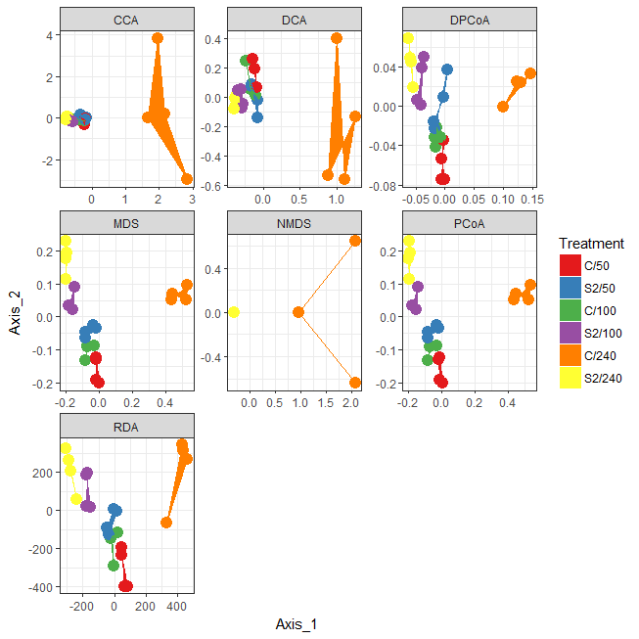

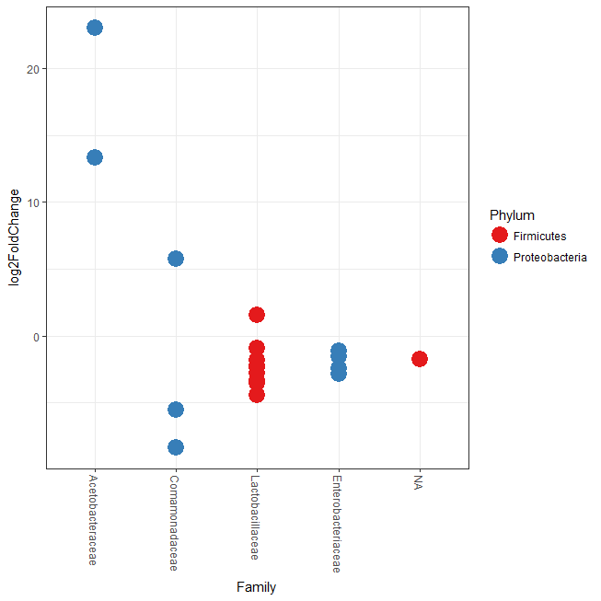

|  |  |  |  |  |  |  |  |  |  |  |  |  |  |
| --- | --- | --- | --- | --- | --- | --- | --- | --- | --- | --- | --- | --- | --- |
| OUT | baseMean | log2FoldChange | lfcSE | stat | pvalue | padj | Kingdom | Phylum | Class | Order | Family | Genus | Species |
| New.CleanUp.ReferenceOTU16301 | 24.75084313 | 1.596578355 | 0.225607896 | 7.076784037 | 1.48E-12 | 4.43E-10 | Bacteria | Firmicutes | Bacilli | Lactobacillales | Lactobacillaceae | Lactobacillus | NA |
| New.CleanUp.ReferenceOTU3240 | 0.97439107 | -4.394633325 | 1.272562185 | -3.453374126 | 0.000553621 | 0.009217783 | Bacteria | Firmicutes | Bacilli | Lactobacillales | Lactobacillaceae | Lactobacillus | brevis |
| 552376 | 12.98561625 | -2.815095834 | 0.77414425 | -3.636397008 | 0.000276478 | 0.005415718 | Bacteria | Proteobacteria | Gammaproteobacteria | Enterobacteriales | Enterobacteriaceae | NA | NA |
| 813217 | 20.67296785 | -1.538585986 | 0.428830623 | -3.587864077 | 0.000333398 | 0.006167863 | Bacteria | Proteobacteria | Gammaproteobacteria | Enterobacteriales | Enterobacteriaceae | Klebsiella | NA |
| 810831 | 4.972350602 | -2.420936156 | 0.692883192 | -3.494003296 | 0.000475835 | 0.008339637 | Bacteria | Proteobacteria | Gammaproteobacteria | Enterobacteriales | Enterobacteriaceae | Klebsiella | NA |
| New.CleanUp.ReferenceOTU7181 | 5.463775454 | -3.531043274 | 0.685404998 | -5.15176178 | 2.58E-07 | 1.43E-05 | Bacteria | Firmicutes | Bacilli | Lactobacillales | Lactobacillaceae | NA | NA |
| New.CleanUp.ReferenceOTU16496 | 6.411955644 | -2.774519215 | 0.544761608 | -5.093088746 | 3.52E-07 | 1.68E-05 | Bacteria | Firmicutes | Bacilli | Lactobacillales | Lactobacillaceae | Lactobacillus | brevis |
| New.CleanUp.ReferenceOTU18965 | 8.202770231 | -1.72691006 | 0.454387448 | -3.800523248 | 0.000144391 | 0.003205477 | Bacteria | Firmicutes | Bacilli | Lactobacillales | NA | NA | NA |
| New.CleanUp.ReferenceOTU2655 | 15.72933378 | -2.339361317 | 0.431436831 | -5.42225686 | 5.89E-08 | 3.92E-06 | Bacteria | Firmicutes | Bacilli | Lactobacillales | Lactobacillaceae | Lactobacillus | brevis |
| New.CleanUp.ReferenceOTU2128 | 1.581839274 | -5.550054291 | 1.339454781 | -4.143517474 | 3.42E-05 | 0.000813517 | Bacteria | Proteobacteria | Betaproteobacteria | Burkholderiales | Comamonadaceae | Comamonas | NA |
| 558170 | 42.92227936 | -8.376145234 | 1.797181178 | -4.660712751 | 3.15E-06 | 0.000105372 | Bacteria | Proteobacteria | Betaproteobacteria | Burkholderiales | Comamonadaceae | Comamonas | NA |
| 275296 | 4.872182749 | 5.745260677 | 1.577629246 | 3.64170523 | 0.000270838 | 0.005415718 | Bacteria | Proteobacteria | Betaproteobacteria | Burkholderiales | Comamonadaceae | NA | NA |
| 273647 | 62.43562206 | 23.05187253 | 5.10063095 | 4.519415884 | 6.20E-06 | 0.000172079 | Bacteria | Proteobacteria | Alphaproteobacteria | Rhodospirillales | Acetobacteraceae | Acetobacter | NA |
| 605989 | 42981.87901 | 13.3302902 | 2.860665936 | 4.659855607 | 3.16E-06 | 0.000105372 | Bacteria | Proteobacteria | Alphaproteobacteria | Rhodospirillales | Acetobacteraceae | Acetobacter | NA |
| New.CleanUp.ReferenceOTU6116 | 27.0133457 | -1.126762076 | 0.270896816 | -4.159377326 | 3.19E-05 | 0.000813517 | Bacteria | Proteobacteria | Gammaproteobacteria | Enterobacteriales | Enterobacteriaceae | NA | NA |
| 760901 | 248.6676212 | -0.901644439 | 0.149526944 | -6.029979716 | 1.64E-09 | 1.37E-07 | Bacteria | Firmicutes | Bacilli | Lactobacillales | Lactobacillaceae | NA | NA |
| 781576 | 29.33000365 | -0.888112058 | 0.194314219 | -4.570494437 | 4.87E-06 | 0.000147299 | Bacteria | Firmicutes | Bacilli | Lactobacillales | Lactobacillaceae | NA | NA |
| 4429559 | 29.86243722 | -2.211395911 | 0.449655863 | -4.917974148 | 8.74E-07 | 3.64E-05 | Bacteria | Firmicutes | Bacilli | Lactobacillales | Lactobacillaceae | Lactobacillus | brevis |
| 160548 | 27.05449255 | -1.815277042 | 0.259523943 | -6.994641886 | 2.66E-12 | 4.43E-10 | Bacteria | Firmicutes | Bacilli | Lactobacillales | Lactobacillaceae | Lactobacillus | brevis |
| New.CleanUp.ReferenceOTU14175 | 5.749535868 | -3.29286089 | 0.538638494 | -6.113304054 | 9.76E-10 | 1.08E-07 | Bacteria | Firmicutes | Bacilli | Lactobacillales | Lactobacillaceae | Lactobacillus | brevis |

**Safe myco bacteria**

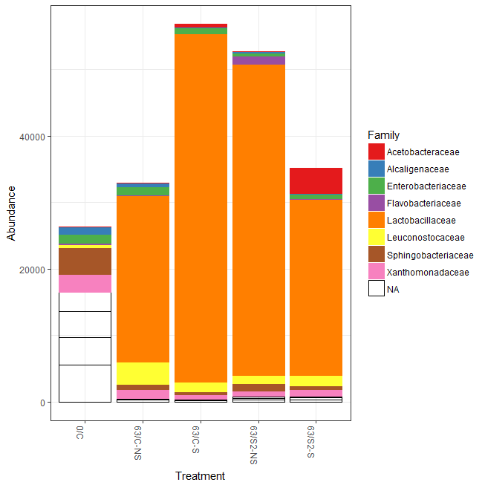

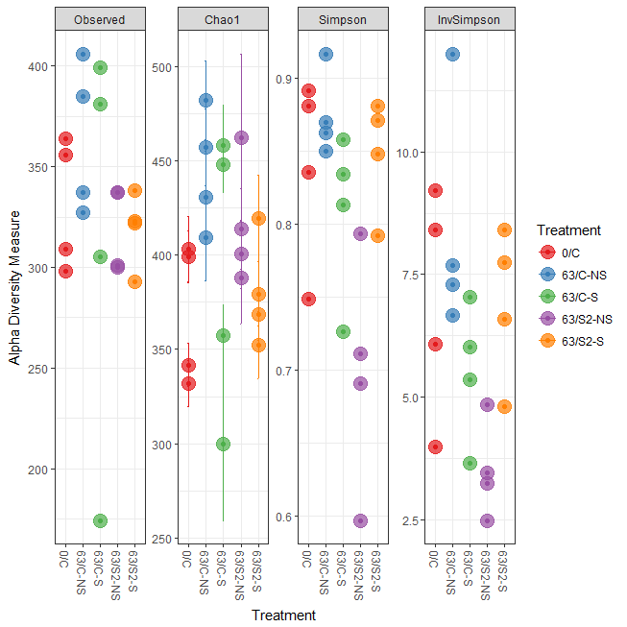

|  |  |  |  |  |  |  |
| --- | --- | --- | --- | --- | --- | --- |
| Samples | Observed | Chao1 | se.chao1 | Shannon | Simpson | InvSimpson |
| 275 | 309 | 341.766 | 11.54143 | 3.009428 | 0.748733 | 3.979824 |
| 276 | 298 | 332.0714 | 12.19289 | 3.490075 | 0.891434 | 9.210976 |
| 277 | 364 | 399.037 | 13.8931 | 3.478014 | 0.835341 | 6.073165 |
| 278 | 356 | 403.2222 | 17.46849 | 3.712997 | 0.881099 | 8.410341 |
| 287 | 337 | 430.3962 | 24.64353 | 3.18728 | 0.849862 | 6.660529 |
| 288 | 327 | 409.0784 | 22.53227 | 3.149692 | 0.862727 | 7.284749 |
| 289 | 385 | 456.9423 | 20.25557 | 3.820979 | 0.916628 | 11.99448 |
| 290 | 406 | 481.8333 | 20.87916 | 3.319505 | 0.869903 | 7.686575 |
| 292 | 399 | 448.1379 | 14.79277 | 3.089304 | 0.834085 | 6.02717 |
| 293 | 174 | 300.1364 | 40.94311 | 2.051308 | 0.726416 | 3.655182 |
| 294 | 381 | 458.0192 | 21.34252 | 2.879345 | 0.813018 | 5.348096 |
| 295 | 305 | 357.1333 | 16.46397 | 2.744765 | 0.858078 | 7.046108 |
| 297 | 337 | 413.7843 | 21.40349 | 2.393088 | 0.710682 | 3.456401 |
| 298 | 300 | 462.303 | 44.26396 | 2.701671 | 0.793506 | 4.842756 |
| 299 | 337 | 400.3818 | 18.12995 | 2.25745 | 0.690739 | 3.233514 |
| 300 | 301 | 388 | 24.71769 | 1.932981 | 0.596432 | 2.477895 |
| 302 | 323 | 368.7797 | 13.98343 | 3.217608 | 0.881004 | 8.403641 |
| 303 | 293 | 352.375 | 17.86919 | 3.137657 | 0.848169 | 6.586249 |
| 304 | 322 | 379.3725 | 17.14319 | 3.103846 | 0.870814 | 7.74077 |
| 305 | 338 | 419.3261 | 23.01302 | 2.733328 | 0.792233 | 4.813089 |

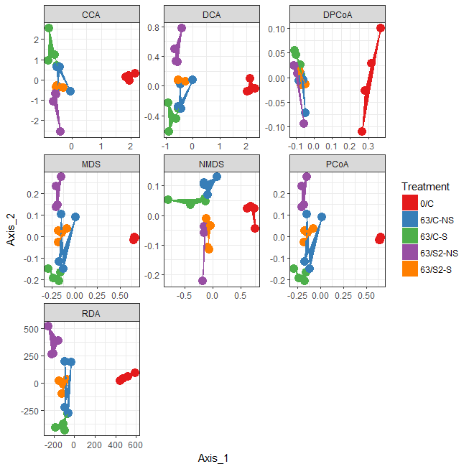



|  |  |  |  |  |  |  |  |  |  |  |  |  |  |
| --- | --- | --- | --- | --- | --- | --- | --- | --- | --- | --- | --- | --- | --- |
| OUT | baseMean | log2FoldChange | lfcSE | stat | pvalue | padj | Kingdom | Phylum | Class | Order | Family | Genus | Species |
| New.CleanUp.ReferenceOTU11182 | 48.31203 | 6.966904 | 1.384647 | 5.03154 | 4.87E-07 | 7.20E-06 | Bacteria | Firmicutes | Bacilli | Lactobacillales | Lactobacillaceae | Lactobacillus | brevis |
| 1110317 | 5329.619 | 11.15382 | 0.879223 | 12.68601 | 7.07E-37 | 1.73E-34 | Bacteria | Firmicutes | Bacilli | Lactobacillales | Lactobacillaceae | Lactobacillus | brevis |
| New.CleanUp.ReferenceOTU14937 | 9.535909 | 6.465985 | 1.265652 | 5.108818 | 3.24E-07 | 5.10E-06 | Bacteria | Firmicutes | Bacilli | Lactobacillales | Lactobacillaceae | Lactobacillus | brevis |
| New.CleanUp.ReferenceOTU19935 | 7.276176 | 6.51924 | 1.432112 | 4.552186 | 5.31E-06 | 5.63E-05 | Bacteria | Firmicutes | Bacilli | Lactobacillales | Lactobacillaceae | Lactobacillus | brevis |
| New.CleanUp.ReferenceOTU22674 | 6.509203 | 5.080298 | 1.228543 | 4.135221 | 3.55E-05 | 0.000327 | Bacteria | Firmicutes | Bacilli | Lactobacillales | Lactobacillaceae | Lactobacillus | brevis |
| New.CleanUp.ReferenceOTU1376 | 1.699725 | -4.93483 | 1.513743 | -3.26002 | 0.001114 | 0.006322 | Bacteria | Proteobacteria | Betaproteobacteria | Burkholderiales | Alcaligenaceae | Achromobacter | NA |
| 275296 | 5.107484 | 5.991403 | 1.655536 | 3.619011 | 0.000296 | 0.001924 | Bacteria | Proteobacteria | Betaproteobacteria | Burkholderiales | Comamonadaceae | Paucibacter | NA |
| New.CleanUp.ReferenceOTU5124 | 26.44024 | -3.43153 | 0.617051 | -5.56118 | 2.68E-08 | 5.23E-07 | Bacteria | Proteobacteria | Betaproteobacteria | Burkholderiales | Comamonadaceae | Delftia | NA |
| 558170 | 52.87125 | 11.24276 | 1.966682 | 5.71661 | 1.09E-08 | 2.21E-07 | Bacteria | Proteobacteria | Betaproteobacteria | Burkholderiales | Comamonadaceae | Comamonas | NA |
| 719367 | 6.334859 | -3.92561 | 0.982418 | -3.99586 | 6.45E-05 | 0.000516 | Bacteria | Proteobacteria | Betaproteobacteria | Burkholderiales | Comamonadaceae | Delftia | NA |
| 580578 | 8.852444 | -2.88233 | 0.789884 | -3.64905 | 0.000263 | 0.001809 | Bacteria | Proteobacteria | Betaproteobacteria | Burkholderiales | Comamonadaceae | Delftia | NA |
| New.CleanUp.ReferenceOTU22713 | 7.210587 | 4.96577 | 1.370272 | 3.62393 | 0.00029 | 0.001913 | Bacteria | Firmicutes | Bacilli | Lactobacillales | Lactobacillaceae | Lactobacillus | brevis |
| New.CleanUp.ReferenceOTU10146 | 11.26676 | 6.733007 | 1.137845 | 5.917331 | 3.27E-09 | 7.60E-08 | Bacteria | Firmicutes | Bacilli | Lactobacillales | Lactobacillaceae | Lactobacillus | NA |
| 153978 | 19.8749 | -3.6036 | 0.735123 | -4.90203 | 9.49E-07 | 1.22E-05 | Bacteria | Cyanobacteria | Chloroplast | Streptophyta | NA | NA | NA |
| 616310 | 532.1712 | -3.2874 | 0.440167 | -7.46853 | 8.11E-14 | 4.95E-12 | Bacteria | Cyanobacteria | Chloroplast | Streptophyta | NA | NA | NA |
| 160548 | 50.16898 | 7.211579 | 1.251336 | 5.763103 | 8.26E-09 | 1.75E-07 | Bacteria | Firmicutes | Bacilli | Lactobacillales | Lactobacillaceae | Lactobacillus | brevis |
| 4429559 | 44.27018 | 7.475874 | 1.377178 | 5.4284 | 5.69E-08 | 1.07E-06 | Bacteria | Firmicutes | Bacilli | Lactobacillales | Lactobacillaceae | Lactobacillus | brevis |
| 604966 | 102.8184 | 6.927556 | 1.129565 | 6.132941 | 8.63E-10 | 2.63E-08 | Bacteria | Firmicutes | Bacilli | Lactobacillales | Lactobacillaceae | Lactobacillus | NA |
| 692823 | 51.37148 | 5.491006 | 1.56282 | 3.513525 | 0.000442 | 0.002732 | Bacteria | Firmicutes | Bacilli | Lactobacillales | Lactobacillaceae | Lactobacillus | brevis |
| 949863 | 833.4233 | 8.212828 | 1.394848 | 5.887975 | 3.91E-09 | 8.67E-08 | Bacteria | Firmicutes | Bacilli | Lactobacillales | Lactobacillaceae | Lactobacillus | NA |
| 633100 | 130.5943 | 6.381267 | 1.395922 | 4.571364 | 4.85E-06 | 5.25E-05 | Bacteria | Firmicutes | Bacilli | Lactobacillales | Lactobacillaceae | Lactobacillus | brevis |
| 4441804 | 5.065851 | 5.24686 | 1.430149 | 3.668752 | 0.000244 | 0.001718 | Bacteria | Firmicutes | Bacilli | Lactobacillales | Lactobacillaceae | Lactobacillus | brevis |
| 744387 | 19.51397 | 5.542863 | 1.384279 | 4.004152 | 6.22E-05 | 0.000515 | Bacteria | Firmicutes | Bacilli | Lactobacillales | Lactobacillaceae | NA | NA |
| New.CleanUp.ReferenceOTU22778 | 107.9178 | 8.29601 | 1.383322 | 5.997165 | 2.01E-09 | 5.16E-08 | Bacteria | Firmicutes | Bacilli | Lactobacillales | Lactobacillaceae | Lactobacillus | NA |
| 354494 | 146.152 | 3.814693 | 1.040578 | 3.665936 | 0.000246 | 0.001718 | Bacteria | Firmicutes | Bacilli | Lactobacillales | Lactobacillaceae | Lactobacillus | NA |
| New.CleanUp.ReferenceOTU20301 | 69.45192 | 4.871985 | 1.284231 | 3.793699 | 0.000148 | 0.001081 | Bacteria | Firmicutes | Bacilli | Lactobacillales | Lactobacillaceae | Lactobacillus | NA |
| 781576 | 55.19719 | 6.517954 | 1.074374 | 6.066743 | 1.31E-09 | 3.75E-08 | Bacteria | Firmicutes | Bacilli | Lactobacillales | Lactobacillaceae | NA | NA |
| 760901 | 347.0458 | 7.458989 | 0.89945 | 8.292838 | 1.11E-16 | 1.35E-14 | Bacteria | Firmicutes | Bacilli | Lactobacillales | Lactobacillaceae | NA | NA |
| New.CleanUp.ReferenceOTU7766 | 19.37701 | 7.453027 | 1.381156 | 5.396223 | 6.81E-08 | 1.19E-06 | Bacteria | Firmicutes | Bacilli | Lactobacillales | Lactobacillaceae | NA | NA |
| 613189 | 61.86003 | 7.91319 | 1.285467 | 6.155886 | 7.47E-10 | 2.43E-08 | Bacteria | Firmicutes | Bacilli | Lactobacillales | Lactobacillaceae | NA | NA |
| 192776 | 15.47476 | 6.12296 | 1.49563 | 4.093899 | 4.24E-05 | 0.000383 | Bacteria | Firmicutes | Bacilli | Lactobacillales | Lactobacillaceae | NA | NA |
| New.CleanUp.ReferenceOTU10156 | 3.524707 | 4.631533 | 1.392784 | 3.325376 | 0.000883 | 0.005069 | Bacteria | Firmicutes | Bacilli | Lactobacillales | Leuconostocaceae | Weissella | NA |
| New.CleanUp.ReferenceOTU5377 | 2.95381 | 5.274834 | 1.309902 | 4.026891 | 5.65E-05 | 0.000476 | Bacteria | Firmicutes | Bacilli | Lactobacillales | Lactobacillaceae | Lactobacillus | NA |
| New.CleanUp.ReferenceOTU2481 | 33.84884 | 6.862774 | 1.144219 | 5.99778 | 2.00E-09 | 5.16E-08 | Bacteria | Firmicutes | Bacilli | Lactobacillales | Lactobacillaceae | Lactobacillus | brevis |
| 544253 | 2.773973 | 5.496751 | 1.324143 | 4.151176 | 3.31E-05 | 0.00031 | Bacteria | Firmicutes | Bacilli | Bacillales | Paenibacillaceae | Paenibacillus | NA |
| 572351 | 10.39373 | 6.420226 | 1.324249 | 4.848202 | 1.25E-06 | 1.52E-05 | Bacteria | Firmicutes | Bacilli | Bacillales | Paenibacillaceae | Paenibacillus | NA |
| 276959 | 3.885816 | 6.028589 | 1.315874 | 4.581435 | 4.62E-06 | 5.12E-05 | Bacteria | Firmicutes | Bacilli | Bacillales | Paenibacillaceae | Paenibacillus | NA |
| 28736 | 7.457649 | 6.158538 | 1.18898 | 5.179683 | 2.22E-07 | 3.64E-06 | Bacteria | Firmicutes | Bacilli | Bacillales | Paenibacillaceae | Paenibacillus | NA |
| 42642 | 5.684529 | 6.349146 | 1.275689 | 4.977034 | 6.46E-07 | 9.00E-06 | Bacteria | Firmicutes | Bacilli | Bacillales | Paenibacillaceae | Paenibacillus | NA |
| 4401692 | 9.804712 | 5.755616 | 0.92702 | 6.208729 | 5.34E-10 | 1.86E-08 | Bacteria | Firmicutes | Bacilli | Bacillales | Bacillaceae | Bacillus | NA |
| 809188 | 12.0061 | 5.935709 | 1.189888 | 4.988459 | 6.09E-07 | 8.74E-06 | Bacteria | Firmicutes | Bacilli | Bacillales | Bacillaceae | Bacillus | NA |
| 558132 | 4.801981 | 3.983422 | 1.063287 | 3.746329 | 0.000179 | 0.001288 | Bacteria | Firmicutes | Bacilli | Bacillales | Bacillaceae | Bacillus | NA |
| New.CleanUp.ReferenceOTU22152 | 4.827869 | 6.365399 | 1.302136 | 4.888428 | 1.02E-06 | 1.27E-05 | Bacteria | Firmicutes | Bacilli | Bacillales | Bacillaceae | Bacillus | NA |
| New.CleanUp.ReferenceOTU20069 | 2.138659 | -4.78499 | 1.317682 | -3.63137 | 0.000282 | 0.001908 | Bacteria | Cyanobacteria | Chloroplast | Streptophyta | NA | NA | NA |
| 1108350 | 11.60201 | -2.55104 | 0.669165 | -3.81228 | 0.000138 | 0.001018 | Bacteria | Actinobacteria | Actinobacteria | Actinomycetales | Microbacteriaceae | Microbacterium | NA |
| 790384 | 2.007515 | -4.01306 | 1.277267 | -3.14192 | 0.001678 | 0.008622 | Bacteria | Actinobacteria | Actinobacteria | Actinomycetales | Microbacteriaceae | Curtobacterium | NA |
| 817734 | 16.58203 | -4.36412 | 1.042917 | -4.18453 | 2.86E-05 | 0.000273 | Bacteria | Proteobacteria | Gammaproteobacteria | Pseudomonadales | Pseudomonadaceae | Pseudomonas | NA |
| New.CleanUp.ReferenceOTU15224 | 1.951603 | -5.24907 | 1.446762 | -3.62815 | 0.000285 | 0.001908 | Bacteria | Proteobacteria | Betaproteobacteria | Burkholderiales | Alcaligenaceae | Achromobacter | NA |
| 558264 | 39.41382 | -2.04596 | 0.658247 | -3.10819 | 0.001882 | 0.00947 | Bacteria | Proteobacteria | Betaproteobacteria | Burkholderiales | Alcaligenaceae | Achromobacter | NA |
| 565246 | 43.41093 | -2.41973 | 0.758126 | -3.19172 | 0.001414 | 0.007584 | Bacteria | Proteobacteria | Betaproteobacteria | Burkholderiales | Alcaligenaceae | Achromobacter | NA |
| New.CleanUp.ReferenceOTU4354 | 2.862601 | -4.34114 | 1.370363 | -3.16788 | 0.001536 | 0.008058 | Bacteria | Proteobacteria | Betaproteobacteria | Burkholderiales | Comamonadaceae | NA | NA |
| New.CleanUp.ReferenceOTU10879 | 2.278496 | 5.651109 | 1.461346 | 3.867059 | 0.00011 | 0.00084 | Bacteria | Proteobacteria | Alphaproteobacteria | Sphingomonadales | Sphingomonadaceae | Sphingomonas | NA |
| New.CleanUp.ReferenceOTU14543 | 4.460871 | 3.778754 | 1.061605 | 3.559472 | 0.000372 | 0.002325 | Bacteria | Proteobacteria | Alphaproteobacteria | Sphingomonadales | Sphingomonadaceae | Sphingomonas | yabuuchiae |
| 1108960 | 42.73538 | 3.234554 | 0.65415 | 4.944669 | 7.63E-07 | 1.01E-05 | Bacteria | Proteobacteria | Alphaproteobacteria | Sphingomonadales | Sphingomonadaceae | Sphingomonas | NA |
| New.CleanUp.ReferenceOTU2999 | 2.230073 | 4.714182 | 1.500325 | 3.142108 | 0.001677 | 0.008622 | Bacteria | Proteobacteria | Alphaproteobacteria | Sphingomonadales | Sphingomonadaceae | Sphingomonas | yabuuchiae |
| New.CleanUp.ReferenceOTU10525 | 2.020858 | -5.19517 | 1.49564 | -3.47354 | 0.000514 | 0.003057 | Bacteria | Bacteroidetes | Sphingobacteriia | Sphingobacteriales | Sphingobacteriaceae | Sphingobacterium | multivorum |
| New.CleanUp.ReferenceOTU22845 | 2.010193 | -4.79672 | 1.497172 | -3.20385 | 0.001356 | 0.007435 | Bacteria | Bacteroidetes | Sphingobacteriia | Sphingobacteriales | Sphingobacteriaceae | Sphingobacterium | multivorum |
| New.CleanUp.ReferenceOTU17170 | 5.830064 | 4.074989 | 1.138104 | 3.580507 | 0.000343 | 0.002202 | Bacteria | Bacteroidetes | Sphingobacteriia | Sphingobacteriales | Sphingobacteriaceae | Sphingobacterium | multivorum |
| 4395986 | 20.12857 | 3.125373 | 0.651301 | 4.798664 | 1.60E-06 | 1.87E-05 | Bacteria | Bacteroidetes | Flavobacteriia | Flavobacteriales | [Weeksellaceae] | Chryseobacterium | NA |
| 706432 | 8.069527 | 3.537687 | 1.015623 | 3.483267 | 0.000495 | 0.002984 | Bacteria | Proteobacteria | Gammaproteobacteria | Pseudomonadales | Moraxellaceae | Acinetobacter | rhizosphaerae |
| 889025 | 50.73772 | 18.31069 | 4.688075 | 3.905802 | 9.39E-05 | 0.000739 | Bacteria | Proteobacteria | Gammaproteobacteria | Pseudomonadales | Moraxellaceae | Acinetobacter | NA |
| New.CleanUp.ReferenceOTU9253 | 5.784377 | 5.338357 | 1.31848 | 4.048872 | 5.15E-05 | 0.000441 | Bacteria | Proteobacteria | Gammaproteobacteria | Enterobacteriales | Enterobacteriaceae | NA | NA |
| New.CleanUp.ReferenceOTU12690 | 20.75308 | 4.165895 | 0.824387 | 5.053323 | 4.34E-07 | 6.62E-06 | Bacteria | Proteobacteria | Gammaproteobacteria | Enterobacteriales | Enterobacteriaceae | NA | NA |
| New.CleanUp.ReferenceOTU2063 | 7.800917 | 3.472422 | 0.902302 | 3.848403 | 0.000119 | 0.000893 | Bacteria | Proteobacteria | Gammaproteobacteria | Xanthomonadales | Xanthomonadaceae | Stenotrophomonas | NA |
| 219439 | 4.24831 | -3.16095 | 0.996616 | -3.17168 | 0.001516 | 0.008039 | Bacteria | Proteobacteria | Gammaproteobacteria | Xanthomonadales | Xanthomonadaceae | Stenotrophomonas | NA |
| 102348 | 1.507146 | -4.39007 | 1.276348 | -3.43956 | 0.000583 | 0.003426 | Bacteria | Proteobacteria | Alphaproteobacteria | Rhodospirillales | Acetobacteraceae | NA | NA |
| 605989 | 336.4333 | 11.79161 | 2.383948 | 4.946256 | 7.57E-07 | 1.01E-05 | Bacteria | Proteobacteria | Alphaproteobacteria | Rhodospirillales | Acetobacteraceae | Acetobacter | NA |
| New.CleanUp.ReferenceOTU14912 | 17.67654 | 8.75985 | 2.191658 | 3.996906 | 6.42E-05 | 0.000516 | Bacteria | Proteobacteria | Alphaproteobacteria | Rhizobiales | Phyllobacteriaceae | NA | NA |
| New.CleanUp.ReferenceOTU20987 | 4.150714 | 5.610217 | 1.238267 | 4.530701 | 5.88E-06 | 5.98E-05 | Bacteria | Firmicutes | Clostridia | Clostridiales | Lachnospiraceae | NA | NA |
| 585881 | 10.99599 | 5.218901 | 0.87455 | 5.967524 | 2.41E-09 | 5.88E-08 | Bacteria | Firmicutes | Clostridia | Clostridiales | Lachnospiraceae | Coprococcus | NA |
| 806407 | 1.900153 | 4.554197 | 1.338676 | 3.402017 | 0.000669 | 0.003886 | Bacteria | Firmicutes | Clostridia | Clostridiales | Lachnospiraceae | NA | NA |
| New.CleanUp.ReferenceOTU18956 | 17.19949 | 4.300962 | 0.630878 | 6.81742 | 9.27E-12 | 3.77E-10 | Bacteria | Firmicutes | Clostridia | Clostridiales | Lachnospiraceae | NA | NA |
| 1107385 | 80.14715 | 9.898517 | 1.245029 | 7.950429 | 1.86E-15 | 1.81E-13 | Bacteria | Firmicutes | Bacilli | Lactobacillales | Lactobacillaceae | Lactobacillus | NA |
| New.CleanUp.ReferenceOTU15023 | 5.998608 | 4.876863 | 1.527895 | 3.191883 | 0.001413 | 0.007584 | Bacteria | Firmicutes | Bacilli | Lactobacillales | Lactobacillaceae | Lactobacillus | NA |
| 4168094 | 309.0542 | 9.99785 | 1.303017 | 7.672845 | 1.68E-14 | 1.17E-12 | Bacteria | Firmicutes | Bacilli | Lactobacillales | Lactobacillaceae | Lactobacillus | NA |
| New.CleanUp.ReferenceOTU17898 | 81.05671 | 5.692721 | 1.464326 | 3.887605 | 0.000101 | 0.000784 | Bacteria | Firmicutes | Bacilli | Lactobacillales | Lactobacillaceae | Lactobacillus | NA |
| New.CleanUp.ReferenceOTU21372 | 4.841905 | 5.038118 | 1.43534 | 3.510052 | 0.000448 | 0.002733 | Bacteria | Firmicutes | Bacilli | Lactobacillales | Lactobacillaceae | Lactobacillus | NA |
| New.CleanUp.ReferenceOTU20798 | 7.590738 | 6.473918 | 1.357103 | 4.770397 | 1.84E-06 | 2.09E-05 | Bacteria | Firmicutes | Bacilli | Lactobacillales | Lactobacillaceae | Lactobacillus | NA |
| New.CleanUp.ReferenceOTU8492 | 2.426785 | 5.161538 | 1.447456 | 3.565937 | 0.000363 | 0.002298 | Bacteria | Firmicutes | Bacilli | Lactobacillales | Lactobacillaceae | Lactobacillus | NA |
| New.CleanUp.ReferenceOTU4075 | 1.928851 | 4.617081 | 1.439436 | 3.207563 | 0.001339 | 0.007423 | Bacteria | Firmicutes | Bacilli | Lactobacillales | Lactobacillaceae | Lactobacillus | NA |
| New.CleanUp.ReferenceOTU6549 | 4.583421 | 5.567518 | 1.300283 | 4.281775 | 1.85E-05 | 0.000181 | Bacteria | Firmicutes | Bacilli | Lactobacillales | Lactobacillaceae | Lactobacillus | NA |
| New.CleanUp.ReferenceOTU22259 | 2.26362 | 4.798964 | 1.494989 | 3.210033 | 0.001327 | 0.007423 | Bacteria | Firmicutes | Bacilli | Lactobacillales | Lactobacillaceae | Lactobacillus | NA |
| 4358818 | 114.3123 | 9.829452 | 1.323986 | 7.424138 | 1.14E-13 | 6.16E-12 | Bacteria | Firmicutes | Bacilli | Lactobacillales | Lactobacillaceae | Lactobacillus | NA |
| 24271 | 5636.854 | 12.34874 | 0.931535 | 13.25633 | 4.15E-40 | 2.02E-37 | Bacteria | Firmicutes | Bacilli | Lactobacillales | Lactobacillaceae | Lactobacillus | NA |
| New.CleanUp.ReferenceOTU11351 | 152.2923 | 9.081135 | 1.299954 | 6.985735 | 2.83E-12 | 1.26E-10 | Bacteria | Firmicutes | Bacilli | Lactobacillales | Lactobacillaceae | Lactobacillus | NA |
| New.CleanUp.ReferenceOTU22872 | 20.1835 | 6.700335 | 1.500524 | 4.46533 | 7.99E-06 | 7.96E-05 | Bacteria | Firmicutes | Bacilli | Lactobacillales | Lactobacillaceae | Lactobacillus | NA |
| New.CleanUp.ReferenceOTU19878 | 3.812352 | 5.407494 | 1.329626 | 4.066929 | 4.76E-05 | 0.000423 | Bacteria | Firmicutes | Bacilli | Lactobacillales | Lactobacillaceae | NA | NA |
| New.CleanUp.ReferenceOTU13951 | 38.70132 | 7.960035 | 1.17356 | 6.78281 | 1.18E-11 | 4.42E-10 | Bacteria | Firmicutes | Bacilli | Lactobacillales | Lactobacillaceae | Lactobacillus | NA |
| New.CleanUp.ReferenceOTU4379 | 67.88896 | 8.048212 | 1.125505 | 7.150757 | 8.63E-13 | 4.21E-11 | Bacteria | Firmicutes | Bacilli | Lactobacillales | Leuconostocaceae | NA | NA |
| 564704 | 13.43043 | 4.313832 | 0.79948 | 5.395797 | 6.82E-08 | 1.19E-06 | Bacteria | Firmicutes | Bacilli | Lactobacillales | Leuconostocaceae | NA | NA |
| 339358 | 293.7438 | 3.134346 | 0.399209 | 7.851388 | 4.11E-15 | 3.35E-13 | Bacteria | Firmicutes | Bacilli | Lactobacillales | Leuconostocaceae | NA | NA |
| New.CleanUp.ReferenceOTU22698 | 13.82759 | 6.014337 | 1.161439 | 5.178351 | 2.24E-07 | 3.64E-06 | Bacteria | Firmicutes | Bacilli | Lactobacillales | Leuconostocaceae | NA | NA |
| 352468 | 121.5708 | 3.97518 | 0.467401 | 8.504855 | 1.82E-17 | 2.96E-15 | Bacteria | Firmicutes | Bacilli | Lactobacillales | Leuconostocaceae | Weissella | NA |
| 663969 | 9.193564 | 3.779945 | 0.833467 | 4.535208 | 5.75E-06 | 5.98E-05 | Bacteria | Firmicutes | Bacilli | Lactobacillales | Leuconostocaceae | Weissella | NA |
| New.CleanUp.ReferenceOTU3173 | 2.214968 | 4.429793 | 1.420179 | 3.119179 | 0.001814 | 0.009219 | Bacteria | Firmicutes | Bacilli | Lactobacillales | Leuconostocaceae | NA | NA |
| New.CleanUp.ReferenceOTU8735 | 6.162219 | 5.264379 | 1.298727 | 4.053491 | 5.05E-05 | 0.00044 | Bacteria | Firmicutes | Bacilli | Lactobacillales | Leuconostocaceae | NA | NA |
| New.CleanUp.ReferenceOTU18234 | 5.73962 | 5.756845 | 1.200058 | 4.79714 | 1.61E-06 | 1.87E-05 | Bacteria | Firmicutes | Bacilli | Lactobacillales | Lactobacillaceae | Lactobacillus | NA |
| New.CleanUp.ReferenceOTU14310 | 6.401784 | 4.473659 | 1.44583 | 3.09418 | 0.001974 | 0.009828 | Bacteria | Firmicutes | Bacilli | Lactobacillales | Lactobacillaceae | Lactobacillus | NA |

**Safe myco post bacteria**



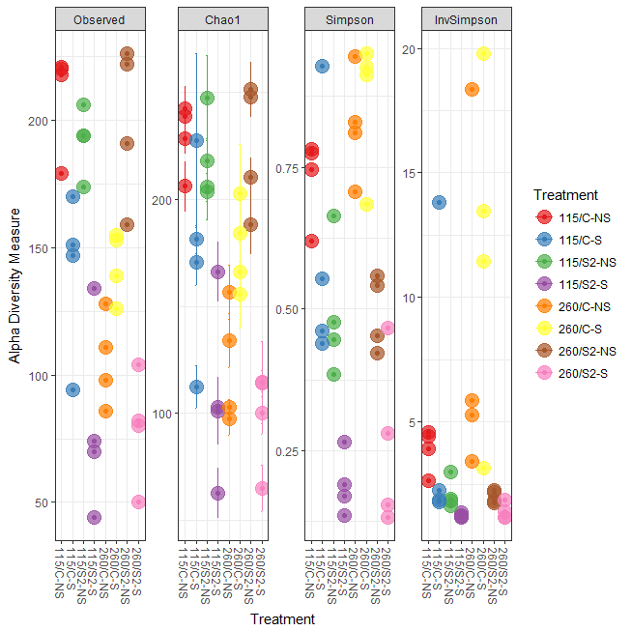

|  |  |  |  |  |  |  |
| --- | --- | --- | --- | --- | --- | --- |
| sample | Observed | Chao1 | se.chao1 | Shannon | Simpson | InvSimpson |
| 849 | 218 | 228 | 6.657587 | 2.750238 | 0.774031 | 4.425378 |
| 850 | 221 | 238.7692 | 10.01714 | 2.57132 | 0.780982 | 4.565841 |
| 851 | 220 | 242.1429 | 10.47652 | 2.589673 | 0.745552 | 3.93008 |
| 852 | 179 | 206.0385 | 11.53732 | 1.830718 | 0.620226 | 2.633148 |
| 854 | 147 | 227.1429 | 40.55211 | 1.429275 | 0.461014 | 1.855336 |
| 855 | 94 | 112.4 | 9.916455 | 1.048965 | 0.439468 | 1.784021 |
| 856 | 170 | 181.1765 | 6.663213 | 3.381812 | 0.927559 | 13.80433 |
| 857 | 151 | 170.4615 | 10.73405 | 1.784633 | 0.553091 | 2.237592 |
| 859 | 194 | 217.8 | 10.59211 | 1.296394 | 0.385397 | 1.627068 |
| 860 | 194 | 205.5 | 6.42574 | 1.521565 | 0.446087 | 1.805337 |
| 861 | 206 | 247.3333 | 19.80523 | 1.617763 | 0.477313 | 1.913191 |
| 862 | 174 | 203.5263 | 13.36649 | 1.706034 | 0.664507 | 2.980685 |
| 864 | 44 | 63 | 11.60931 | 0.436021 | 0.191232 | 1.236449 |
| 865 | 70 | 101.2308 | 15.4837 | 0.520954 | 0.170426 | 1.205438 |
| 866 | 74 | 103.0625 | 13.82478 | 0.376776 | 0.135906 | 1.157282 |
| 867 | 134 | 166.2174 | 13.5879 | 0.832378 | 0.266072 | 1.362532 |
| 869 | 128 | 156.3333 | 12.61643 | 2.574479 | 0.810453 | 5.275738 |
| 870 | 86 | 97.33333 | 7.297782 | 1.856631 | 0.706483 | 3.406958 |
| 871 | 98 | 102.875 | 3.767914 | 3.387792 | 0.945568 | 18.37146 |
| 872 | 111 | 134 | 12.76225 | 2.345483 | 0.829267 | 5.857084 |
| 874 | 139 | 166.1875 | 13.13157 | 3.53259 | 0.949435 | 19.77659 |
| 875 | 155 | 184.25 | 15.04023 | 3.567538 | 0.925786 | 13.47461 |
| 876 | 153 | 202.5833 | 22.94621 | 3.263221 | 0.912602 | 11.4419 |
| 877 | 126 | 155.5455 | 15.53434 | 2.334627 | 0.683614 | 3.160693 |
| 879 | 159 | 188.1765 | 13.64318 | 1.969039 | 0.559074 | 2.267954 |
| 880 | 191 | 210.0769 | 8.916142 | 1.391802 | 0.42153 | 1.7287 |
| 881 | 226 | 247.6667 | 9.082677 | 1.81851 | 0.541367 | 2.180391 |
| 882 | 222 | 251.2917 | 12.50238 | 1.497914 | 0.453496 | 1.829812 |
| 884 | 104 | 114.0588 | 6.176548 | 0.841023 | 0.281632 | 1.392045 |
| 885 | 80 | 114.5 | 19.27388 | 1.225306 | 0.46628 | 1.87364 |
| 886 | 82 | 100.4 | 9.916235 | 0.37377 | 0.132082 | 1.152183 |
| 887 | 50 | 65.16667 | 10.85267 | 0.423139 | 0.155246 | 1.183777 |





|  |  |  |  |  |  |  |  |  |  |  |  |  |  |
| --- | --- | --- | --- | --- | --- | --- | --- | --- | --- | --- | --- | --- | --- |
| OUT | baseMean | log2FoldChange | lfcSE | stat | pvalue | padj | Kingdom | Phylum | Class | Order | Family | Genus | Species |
| 156232 | 7373.017 | 6.558755 | 2.086772 | 3.143014 | 0.001672 | 0.005044 | Bacteria | Proteobacteria | Alphaproteobacteria | Rhodospirillales | Acetobacteraceae | NA | NA |
| New.CleanUp.ReferenceOTU14745 | 20.49769 | 11.32829 | 1.704676 | 6.645423 | 3.02E-11 | 3.53E-10 | Bacteria | Proteobacteria | Alphaproteobacteria | Rhodospirillales | Acetobacteraceae | Acetobacter | NA |
| New.CleanUp.ReferenceOTU4493 | 17.80338 | 13.17166 | 1.859593 | 7.083087 | 1.41E-12 | 2.13E-11 | Bacteria | Proteobacteria | Alphaproteobacteria | Rhodospirillales | Acetobacteraceae | Acetobacter | NA |
| New.CleanUp.ReferenceOTU3282 | 76.1269 | 5.44518 | 1.620254 | 3.360696 | 0.000777 | 0.002559 | Bacteria | Proteobacteria | Alphaproteobacteria | Rhodospirillales | Acetobacteraceae | Acetobacter | NA |
| New.CleanUp.ReferenceOTU3266 | 27.47502 | 11.28047 | 2.061597 | 5.471716 | 4.46E-08 | 3.36E-07 | Bacteria | Proteobacteria | Alphaproteobacteria | Rhodospirillales | Acetobacteraceae | Acetobacter | NA |
| New.CleanUp.ReferenceOTU13353 | 119.6255 | 9.535876 | 1.552732 | 6.141354 | 8.18E-10 | 8.23E-09 | Bacteria | Firmicutes | Clostridia | Clostridiales | Lachnospiraceae | NA | NA |
| New.CleanUp.ReferenceOTU19460 | 374.7085 | 8.165568 | 1.092803 | 7.472129 | 7.89E-14 | 1.59E-12 | Bacteria | Firmicutes | Clostridia | Clostridiales | Lachnospiraceae | NA | NA |
| 806407 | 41.28128 | 8.557106 | 1.680967 | 5.090586 | 3.57E-07 | 2.19E-06 | Bacteria | Firmicutes | Clostridia | Clostridiales | Lachnospiraceae | NA | NA |
| New.CleanUp.ReferenceOTU1737 | 944.352 | 30 | 5.856793 | 5.122257 | 3.02E-07 | 1.95E-06 | Bacteria | Proteobacteria | Gammaproteobacteria | Enterobacteriales | Enterobacteriaceae | NA | NA |
| New.CleanUp.ReferenceOTU10918 | 74.67214 | 14.86479 | 1.840018 | 8.078614 | 6.55E-16 | 1.98E-14 | Bacteria | Firmicutes | Bacilli | Bacillales | Bacillaceae | Bacillus | NA |
| 14592 | 138.4641 | 15.41131 | 1.884677 | 8.177164 | 2.91E-16 | 9.56E-15 | Bacteria | Firmicutes | Bacilli | Bacillales | Bacillaceae | Bacillus | NA |
| 137950 | 8.204138 | 9.619078 | 2.307317 | 4.168945 | 3.06E-05 | 0.00013 | Bacteria | Firmicutes | Bacilli | Bacillales | Bacillaceae | Bacillus | NA |
| 590554 | 52.80301 | 14.93044 | 3.458104 | 4.317521 | 1.58E-05 | 7.42E-05 | Bacteria | Firmicutes | Bacilli | Bacillales | Planococcaceae | Rummeliibacillus | NA |
| New.CleanUp.ReferenceOTU22595 | 36.38996 | 14.07325 | 1.857024 | 7.57839 | 3.50E-14 | 8.42E-13 | Bacteria | Firmicutes | Bacilli | Bacillales | Bacillaceae | Bacillus | coagulans |
| New.CleanUp.ReferenceOTU12256 | 7.706639 | 8.495687 | 2.566879 | 3.309734 | 0.000934 | 0.003018 | Bacteria | Firmicutes | Bacilli | Bacillales | Paenibacillaceae | Paenibacillus | NA |
| New.CleanUp.ReferenceOTU12821 | 23.49442 | 11.87805 | 2.282825 | 5.203225 | 1.96E-07 | 1.36E-06 | Bacteria | Firmicutes | Bacilli | Bacillales | Paenibacillaceae | Paenibacillus | NA |
| 42642 | 355.2026 | 7.014051 | 1.416483 | 4.951737 | 7.36E-07 | 4.37E-06 | Bacteria | Firmicutes | Bacilli | Bacillales | Paenibacillaceae | Paenibacillus | NA |
| New.CleanUp.ReferenceOTU8826 | 3.290607 | 7.952013 | 2.071821 | 3.838175 | 0.000124 | 0.000477 | Bacteria | Firmicutes | Bacilli | Bacillales | NA | NA | NA |
| New.CleanUp.ReferenceOTU13480 | 14.48581 | 9.566996 | 2.983133 | 3.207029 | 0.001341 | 0.004114 | Bacteria | Firmicutes | Bacilli | Bacillales | Paenibacillaceae | Paenibacillus | NA |
| New.CleanUp.ReferenceOTU17797 | 7.045937 | 9.925975 | 2.256454 | 4.398926 | 1.09E-05 | 5.32E-05 | Bacteria | Firmicutes | Bacilli | Bacillales | Paenibacillaceae | Paenibacillus | NA |
| 572351 | 54.64712 | 4.690205 | 1.460012 | 3.212443 | 0.001316 | 0.004072 | Bacteria | Firmicutes | Bacilli | Bacillales | Paenibacillaceae | Paenibacillus | NA |
| New.CleanUp.ReferenceOTU8976 | 0.301502 | 7.788703 | 2.533474 | 3.074317 | 0.00211 | 0.00626 | Bacteria | Firmicutes | Bacilli | Bacillales | Paenibacillaceae | Paenibacillus | NA |
| New.CleanUp.ReferenceOTU24679 | 24.51039 | 9.777514 | 2.641947 | 3.700875 | 0.000215 | 0.000806 | Bacteria | Firmicutes | Bacilli | Bacillales | Paenibacillaceae | Paenibacillus | NA |
| New.CleanUp.ReferenceOTU15013 | 5.1691 | 9.765343 | 1.999961 | 4.882768 | 1.05E-06 | 6.01E-06 | Bacteria | Firmicutes | Bacilli | Bacillales | Paenibacillaceae | Paenibacillus | NA |
| New.CleanUp.ReferenceOTU20673 | 15.62863 | 9.530679 | 2.27346 | 4.192147 | 2.76E-05 | 0.000119 | Bacteria | Firmicutes | Bacilli | Bacillales | Paenibacillaceae | Paenibacillus | NA |
| 544253 | 343.0499 | 9.571973 | 1.561385 | 6.130436 | 8.76E-10 | 8.57E-09 | Bacteria | Firmicutes | Bacilli | Bacillales | Paenibacillaceae | Paenibacillus | NA |
| 594342 | 27.47577 | 11.59788 | 2.713663 | 4.273884 | 1.92E-05 | 8.80E-05 | Bacteria | Firmicutes | Bacilli | Bacillales | Paenibacillaceae | Paenibacillus | NA |
| 1081222 | 139.4402 | 11.80884 | 1.504988 | 7.846473 | 4.28E-15 | 1.11E-13 | Bacteria | Firmicutes | Bacilli | Bacillales | Paenibacillaceae | Paenibacillus | NA |
| 742248 | 147.6723 | 14.16324 | 2.212212 | 6.402298 | 1.53E-10 | 1.68E-09 | Bacteria | Firmicutes | Bacilli | Bacillales | Paenibacillaceae | Paenibacillus | NA |
| 138130 | 591.7888 | 10.98907 | 1.176108 | 9.343586 | 9.31E-21 | 8.43E-19 | Bacteria | Firmicutes | Bacilli | Bacillales | Paenibacillaceae | Paenibacillus | NA |
| New.CleanUp.ReferenceOTU8904 | 8.474674 | 9.354776 | 1.58117 | 5.916362 | 3.29E-09 | 2.91E-08 | Bacteria | Firmicutes | Bacilli | Bacillales | Paenibacillaceae | Paenibacillus | NA |
| New.CleanUp.ReferenceOTU7229 | 9.208219 | 10.59004 | 3.275336 | 3.233268 | 0.001224 | 0.003819 | Bacteria | Firmicutes | Bacilli | Bacillales | Paenibacillaceae | Paenibacillus | NA |
| New.CleanUp.ReferenceOTU18928 | 44.84344 | 12.81661 | 1.819576 | 7.043734 | 1.87E-12 | 2.71E-11 | Bacteria | Firmicutes | Bacilli | Bacillales | Paenibacillaceae | Paenibacillus | NA |
| New.CleanUp.ReferenceOTU13605 | 13.35605 | 11.25173 | 2.310407 | 4.87002 | 1.12E-06 | 6.31E-06 | Bacteria | Firmicutes | Bacilli | Bacillales | Paenibacillaceae | Paenibacillus | NA |
| New.CleanUp.ReferenceOTU5903 | 56.18682 | 14.28056 | 1.967945 | 7.256585 | 3.97E-13 | 7.30E-12 | Bacteria | Firmicutes | Bacilli | Bacillales | Bacillaceae | Bacillus | NA |
| New.CleanUp.ReferenceOTU33 | 51.68361 | 8.321383 | 2.537086 | 3.279898 | 0.001038 | 0.003298 | Bacteria | Firmicutes | Bacilli | Bacillales | Bacillaceae | Bacillus | NA |
| 821325 | 42.23759 | 11.20794 | 1.920319 | 5.836497 | 5.33E-09 | 4.49E-08 | Bacteria | Firmicutes | Bacilli | Bacillales | Planococcaceae | Lysinibacillus | boronitolerans |
| 816470 | 306.1272 | 12.7249 | 1.754087 | 7.25443 | 4.03E-13 | 7.30E-12 | Bacteria | Firmicutes | Bacilli | Bacillales | Bacillaceae | NA | NA |
| New.CleanUp.ReferenceOTU16986 | 17.42263 | 12.29448 | 1.79218 | 6.860069 | 6.88E-12 | 9.17E-11 | Bacteria | Firmicutes | Bacilli | Bacillales | Bacillaceae | Bacillus | NA |
| New.CleanUp.ReferenceOTU1834 | 554.9217 | 14.91973 | 1.783124 | 8.367186 | 5.90E-17 | 2.14E-15 | Bacteria | Firmicutes | Bacilli | Bacillales | Bacillaceae | NA | NA |
| 334666 | 72.97935 | 10.87741 | 2.05954 | 5.281474 | 1.28E-07 | 9.10E-07 | Bacteria | Firmicutes | Bacilli | Bacillales | Bacillaceae | Bacillus | NA |
| 1078248 | 120.2738 | 10.96719 | 1.927827 | 5.688886 | 1.28E-08 | 1.05E-07 | Bacteria | Firmicutes | Bacilli | Bacillales | Bacillaceae | Bacillus | NA |
| New.CleanUp.ReferenceOTU6927 | 105.674 | 12.923 | 2.306732 | 5.602298 | 2.12E-08 | 1.66E-07 | Bacteria | Firmicutes | Bacilli | Bacillales | Bacillaceae | Bacillus | NA |
| New.CleanUp.ReferenceOTU16126 | 28.80561 | 11.92083 | 3.031473 | 3.932355 | 8.41E-05 | 0.000331 | Bacteria | Firmicutes | Bacilli | Bacillales | Bacillaceae | Bacillus | flexus |
| 823024 | 58.3744 | 14.13953 | 2.157742 | 6.55293 | 5.64E-11 | 6.38E-10 | Bacteria | Firmicutes | Bacilli | Bacillales | Bacillaceae | Bacillus | flexus |
| 833317 | 37.46987 | 12.5199 | 2.967372 | 4.219188 | 2.45E-05 | 0.000108 | Bacteria | Firmicutes | Bacilli | Bacillales | Bacillaceae | Bacillus | flexus |
| 555970 | 5.857109 | 10.31319 | 2.247887 | 4.587947 | 4.48E-06 | 2.35E-05 | Bacteria | Firmicutes | Bacilli | Bacillales | Bacillaceae | Bacillus | NA |
| New.CleanUp.ReferenceOTU7144 | 10.6766 | 9.588187 | 2.381407 | 4.026271 | 5.67E-05 | 0.00023 | Bacteria | Firmicutes | Bacilli | Bacillales | Bacillaceae | Bacillus | NA |
| 1084045 | 376.4607 | 13.07388 | 1.511914 | 8.647237 | 5.28E-18 | 3.18E-16 | Bacteria | Firmicutes | Bacilli | Bacillales | Bacillaceae | Bacillus | NA |
| 1051517 | 885.2784 | 13.28376 | 1.582305 | 8.395199 | 4.65E-17 | 2.10E-15 | Bacteria | Firmicutes | Bacilli | Bacillales | Bacillaceae | Bacillus | NA |
| 909052 | 17.87486 | 12.70227 | 2.461032 | 5.16136 | 2.45E-07 | 1.64E-06 | Bacteria | Firmicutes | Bacilli | Bacillales | Planococcaceae | Lysinibacillus | boronitolerans |
| New.CleanUp.ReferenceOTU13324 | 3.710846 | 9.782246 | 3.26135 | 2.999447 | 0.002705 | 0.007833 | Bacteria | Firmicutes | Bacilli | Lactobacillales | Lactobacillaceae | NA | NA |
| New.CleanUp.ReferenceOTU18443 | 3.458178 | 8.603408 | 1.598656 | 5.38165 | 7.38E-08 | 5.45E-07 | Bacteria | Firmicutes | Bacilli | Lactobacillales | Lactobacillaceae | Lactobacillus | NA |
| New.CleanUp.ReferenceOTU15824 | 0.961415 | 7.108645 | 1.921501 | 3.699527 | 0.000216 | 0.000806 | Bacteria | Firmicutes | Bacilli | Bacillales | Paenibacillaceae | Paenibacillus | lentimorbus |
| 266330 | 9.504015 | 10.5211 | 2.15166 | 4.889759 | 1.01E-06 | 5.89E-06 | Bacteria | Firmicutes | Bacilli | Lactobacillales | Lactobacillaceae | Lactobacillus | zeae |
| 518033 | 15.76448 | 10.4117 | 2.079379 | 5.007118 | 5.53E-07 | 3.33E-06 | Bacteria | Firmicutes | Bacilli | Lactobacillales | Lactobacillaceae | Lactobacillus | zeae |
| New.CleanUp.ReferenceOTU12111 | 9.245776 | 7.053155 | 1.777499 | 3.968022 | 7.25E-05 | 0.000291 | Bacteria | Firmicutes | Bacilli | Lactobacillales | Lactobacillaceae | Lactobacillus | NA |
| 73609 | 404.5871 | 11.90385 | 1.204606 | 9.881947 | 4.99E-23 | 6.02E-21 | Bacteria | Firmicutes | Bacilli | Lactobacillales | Lactobacillaceae | Lactobacillus | zeae |
| 1110317 | 301.5411 | 2.883583 | 0.64585 | 4.464789 | 8.01E-06 | 4.09E-05 | Bacteria | Firmicutes | Bacilli | Lactobacillales | Lactobacillaceae | Lactobacillus | brevis |
| 160548 | 19.13531 | 7.652216 | 1.443365 | 5.301649 | 1.15E-07 | 8.31E-07 | Bacteria | Firmicutes | Bacilli | Lactobacillales | Lactobacillaceae | Lactobacillus | brevis |
| 4429559 | 5.396475 | 4.588779 | 1.306665 | 3.511825 | 0.000445 | 0.001541 | Bacteria | Firmicutes | Bacilli | Lactobacillales | Lactobacillaceae | Lactobacillus | brevis |
| 581189 | 0.925802 | 4.547533 | 1.263473 | 3.599233 | 0.000319 | 0.001144 | Bacteria | Firmicutes | Bacilli | Lactobacillales | Lactobacillaceae | Lactobacillus | brevis |
| 949863 | 94.49394 | 3.081983 | 0.710929 | 4.335148 | 1.46E-05 | 6.94E-05 | Bacteria | Firmicutes | Bacilli | Lactobacillales | Lactobacillaceae | Lactobacillus | NA |
| New.CleanUp.ReferenceOTU22078 | 48.51563 | 7.216913 | 2.010657 | 3.589331 | 0.000332 | 0.001177 | Bacteria | Firmicutes | Bacilli | Lactobacillales | Lactobacillaceae | Lactobacillus | brevis |
| New.CleanUp.ReferenceOTU17342 | 10.09552 | 9.523611 | 2.193579 | 4.341587 | 1.41E-05 | 6.83E-05 | Bacteria | Firmicutes | Bacilli | Lactobacillales | Lactobacillaceae | Lactobacillus | zeae |
| 633100 | 5.691356 | 2.807848 | 0.953159 | 2.945834 | 0.003221 | 0.009254 | Bacteria | Firmicutes | Bacilli | Lactobacillales | Lactobacillaceae | Lactobacillus | brevis |
| 588197 | 11.20165 | 6.337611 | 1.349382 | 4.696675 | 2.64E-06 | 1.43E-05 | Bacteria | Firmicutes | Bacilli | Lactobacillales | Lactobacillaceae | Lactobacillus | NA |
| 604966 | 195.2783 | 8.682956 | 1.036297 | 8.378831 | 5.35E-17 | 2.14E-15 | Bacteria | Firmicutes | Bacilli | Lactobacillales | Lactobacillaceae | Lactobacillus | NA |
| 781576 | 50.16423 | 7.652408 | 1.268147 | 6.034321 | 1.60E-09 | 1.48E-08 | Bacteria | Firmicutes | Bacilli | Lactobacillales | Lactobacillaceae | NA | NA |
| 760901 | 287.244 | 7.806857 | 1.077254 | 7.247 | 4.26E-13 | 7.35E-12 | Bacteria | Firmicutes | Bacilli | Lactobacillales | Lactobacillaceae | NA | NA |
| 613189 | 56.74256 | 8.020898 | 1.169952 | 6.855749 | 7.09E-12 | 9.17E-11 | Bacteria | Firmicutes | Bacilli | Lactobacillales | Lactobacillaceae | NA | NA |
| 192776 | 6.819249 | 6.550201 | 1.75521 | 3.731862 | 0.00019 | 0.000724 | Bacteria | Firmicutes | Bacilli | Lactobacillales | Lactobacillaceae | NA | NA |
| New.CleanUp.ReferenceOTU6529 | 0.309031 | 4.119794 | 1.187827 | 3.468344 | 0.000524 | 0.001788 | Bacteria | Firmicutes | Bacilli | Lactobacillales | Lactobacillaceae | Lactobacillus | NA |
| New.CleanUp.ReferenceOTU20848 | 0.274307 | 5.073905 | 1.253076 | 4.04916 | 5.14E-05 | 0.000211 | Bacteria | Firmicutes | Bacilli | Lactobacillales | Lactobacillaceae | Lactobacillus | NA |
| New.CleanUp.ReferenceOTU9675 | 0.389986 | 5.296393 | 1.546294 | 3.425219 | 0.000614 | 0.002059 | Bacteria | Firmicutes | Bacilli | Lactobacillales | Lactobacillaceae | Lactobacillus | NA |
| New.CleanUp.ReferenceOTU13206 | 3.415003 | 5.79437 | 1.483104 | 3.906921 | 9.35E-05 | 0.000364 | Bacteria | Firmicutes | Bacilli | Lactobacillales | Lactobacillaceae | Pediococcus | NA |
| New.CleanUp.ReferenceOTU10895 | 78.35032 | 14.78379 | 1.952846 | 7.570383 | 3.72E-14 | 8.42E-13 | Bacteria | Firmicutes | Bacilli | Bacillales | Bacillaceae | Bacillus | NA |
| New.CleanUp.ReferenceOTU21471 | 70.73789 | 11.3505 | 1.592899 | 7.125688 | 1.04E-12 | 1.63E-11 | Bacteria | Firmicutes | Bacilli | Bacillales | Bacillaceae | Bacillus | NA |
| 383122 | 15.29482 | 5.921692 | 1.929901 | 3.068392 | 0.002152 | 0.006334 | Bacteria | Firmicutes | Bacilli | Bacillales | Bacillaceae | Bacillus | NA |
| 809188 | 104.0979 | 6.08124 | 1.253538 | 4.85126 | 1.23E-06 | 6.83E-06 | Bacteria | Firmicutes | Bacilli | Bacillales | Bacillaceae | Bacillus | NA |
| 4401692 | 202.5096 | 8.419207 | 1.32586 | 6.349997 | 2.15E-10 | 2.29E-09 | Bacteria | Firmicutes | Bacilli | Bacillales | Bacillaceae | Bacillus | NA |
| 78009 | 23.49021 | 9.373519 | 2.30061 | 4.074362 | 4.61E-05 | 0.000194 | Bacteria | Firmicutes | Bacilli | Bacillales | Bacillaceae | Bacillus | NA |
| New.CleanUp.ReferenceOTU21479 | 6.653372 | 7.277557 | 2.225218 | 3.270492 | 0.001074 | 0.00338 | Bacteria | Firmicutes | Bacilli | Bacillales | Bacillaceae | Bacillus | NA |
| 558132 | 220.1534 | 6.791176 | 1.593546 | 4.261677 | 2.03E-05 | 9.18E-05 | Bacteria | Firmicutes | Bacilli | Bacillales | Bacillaceae | Bacillus | NA |
| 159446 | 2.70632 | -8.99369 | 1.889574 | -4.75964 | 1.94E-06 | 1.06E-05 | Bacteria | Firmicutes | Bacilli | Lactobacillales | Lactobacillaceae | Lactobacillus | NA |
| New.CleanUp.ReferenceOTU919 | 1.192285 | 4.860591 | 1.453902 | 3.343136 | 0.000828 | 0.002702 | Bacteria | Firmicutes | Bacilli | Lactobacillales | Lactobacillaceae | Lactobacillus | brevis |
| 605989 | 225058.9 | 21.39883 | 1.640741 | 13.04217 | 7.04E-39 | 1.27E-36 | Bacteria | Proteobacteria | Alphaproteobacteria | Rhodospirillales | Acetobacteraceae | Acetobacter | NA |
| 4333237 | 9745.537 | 11.89577 | 1.944871 | 6.116484 | 9.57E-10 | 9.11E-09 | Bacteria | Proteobacteria | Alphaproteobacteria | Rhodospirillales | Acetobacteraceae | Acetobacter | NA |
| New.CleanUp.ReferenceOTU5265 | 96.28192 | 14.72498 | 1.856984 | 7.929518 | 2.20E-15 | 6.13E-14 | Bacteria | Proteobacteria | Alphaproteobacteria | Rhodospirillales | Acetobacteraceae | Acetobacter | NA |
| New.CleanUp.ReferenceOTU15776 | 59.19397 | 15.04848 | 2.682824 | 5.609194 | 2.03E-08 | 1.64E-07 | Bacteria | Proteobacteria | Alphaproteobacteria | Rhodospirillales | Acetobacteraceae | Acetobacter | NA |
| New.CleanUp.ReferenceOTU3444 | 53.75207 | 14.59714 | 2.455535 | 5.944586 | 2.77E-09 | 2.51E-08 | Bacteria | Proteobacteria | Alphaproteobacteria | Rhodospirillales | Acetobacteraceae | Acetobacter | NA |
| New.CleanUp.ReferenceOTU11578 | 115.8842 | 15.08582 | 1.759844 | 8.572249 | 1.01E-17 | 5.25E-16 | Bacteria | Proteobacteria | Alphaproteobacteria | Rhodospirillales | Acetobacteraceae | Acetobacter | NA |
| New.CleanUp.ReferenceOTU12499 | 41.18091 | 12.27262 | 1.695586 | 7.237981 | 4.55E-13 | 7.49E-12 | Bacteria | Proteobacteria | Alphaproteobacteria | Rhodospirillales | Acetobacteraceae | NA | NA |
| New.CleanUp.ReferenceOTU15661 | 212.0995 | 16.58684 | 1.783498 | 9.300171 | 1.40E-20 | 1.02E-18 | Bacteria | Proteobacteria | Alphaproteobacteria | Rhodospirillales | Acetobacteraceae | Acetobacter | NA |
| New.CleanUp.ReferenceOTU9206 | 8.441804 | 11.18541 | 1.805789 | 6.194199 | 5.86E-10 | 6.06E-09 | Bacteria | Proteobacteria | Alphaproteobacteria | Rhodospirillales | Acetobacteraceae | Acetobacter | NA |
| New.CleanUp.ReferenceOTU15635 | 211.6835 | 11.5588 | 2.481647 | 4.657715 | 3.20E-06 | 1.70E-05 | Bacteria | Proteobacteria | Alphaproteobacteria | Rhodospirillales | Acetobacteraceae | Acetobacter | NA |
| New.CleanUp.ReferenceOTU17428 | 26.30188 | 9.403022 | 2.555784 | 3.679114 | 0.000234 | 0.000865 | Bacteria | Proteobacteria | Alphaproteobacteria | Rhodospirillales | Acetobacteraceae | Acetobacter | NA |
| 549374 | 305.1699 | 11.18965 | 2.442984 | 4.580319 | 4.64E-06 | 2.40E-05 | Bacteria | Proteobacteria | Alphaproteobacteria | Rhodospirillales | Acetobacteraceae | Acetobacter | NA |
| New.CleanUp.ReferenceOTU1368 | 946.2017 | 10.4054 | 2.026129 | 5.135608 | 2.81E-07 | 1.85E-06 | Bacteria | Proteobacteria | Alphaproteobacteria | Rhodospirillales | Acetobacteraceae | Acetobacter | NA |
| 273647 | 905.1688 | 13.41051 | 2.004494 | 6.690223 | 2.23E-11 | 2.69E-10 | Bacteria | Proteobacteria | Alphaproteobacteria | Rhodospirillales | Acetobacteraceae | Acetobacter | NA |
| New.CleanUp.ReferenceOTU22526 | 736.6251 | 15.32406 | 3.451286 | 4.440102 | 8.99E-06 | 4.46E-05 | Bacteria | Proteobacteria | Alphaproteobacteria | Rhodospirillales | Acetobacteraceae | Acetobacter | NA |
| New.CleanUp.ReferenceOTU10132 | 159.1561 | 28.40026 | 5.558392 | 5.109437 | 3.23E-07 | 2.02E-06 | Bacteria | Proteobacteria | Alphaproteobacteria | Rhodospirillales | Acetobacteraceae | Acetobacter | NA |
| New.CleanUp.ReferenceOTU23243 | 6.051036 | 10.5325 | 2.463547 | 4.275338 | 1.91E-05 | 8.80E-05 | Bacteria | Proteobacteria | Alphaproteobacteria | Rhodospirillales | Acetobacteraceae | Acetobacter | NA |
| New.CleanUp.ReferenceOTU14488 | 17.2364 | 11.60299 | 1.551632 | 7.477924 | 7.55E-14 | 1.59E-12 | Bacteria | Proteobacteria | Alphaproteobacteria | Rhodospirillales | Acetobacteraceae | Acetobacter | NA |
| 234148 | 129.6634 | 24.84931 | 5.89134 | 4.217939 | 2.47E-05 | 0.000108 | Bacteria | Proteobacteria | Gammaproteobacteria | Enterobacteriales | Enterobacteriaceae | Providencia | NA |
| 4484484 | 4528.692 | 18.63607 | 5.069139 | 3.676377 | 0.000237 | 0.000865 | Bacteria | Proteobacteria | Gammaproteobacteria | Enterobacteriales | Enterobacteriaceae | Providencia | NA |
| 610462 | 3477.614 | 25.4701 | 3.785289 | 6.728706 | 1.71E-11 | 2.14E-10 | Bacteria | Proteobacteria | Gammaproteobacteria | Enterobacteriales | Enterobacteriaceae | Providencia | NA |
| 609704 | 253.4068 | 26.08725 | 5.874191 | 4.440995 | 8.95E-06 | 4.46E-05 | Bacteria | Proteobacteria | Gammaproteobacteria | Enterobacteriales | Enterobacteriaceae | NA | NA |
| 1122622 | 29276.23 | 19.88518 | 3.577257 | 5.55878 | 2.72E-08 | 2.09E-07 | Bacteria | Proteobacteria | Gammaproteobacteria | Enterobacteriales | Enterobacteriaceae | NA | NA |
| 814952 | 664.3305 | -9.23381 | 2.630017 | -3.51093 | 0.000447 | 0.001541 | Bacteria | Proteobacteria | Gammaproteobacteria | Enterobacteriales | Enterobacteriaceae | NA | NA |
| 813217 | 3280.188 | -14.9589 | 2.556431 | -5.85148 | 4.87E-09 | 4.20E-08 | Bacteria | Proteobacteria | Gammaproteobacteria | Enterobacteriales | Enterobacteriaceae | NA | NA |
| 813457 | 592.7307 | -9.25331 | 2.891561 | -3.20011 | 0.001374 | 0.004179 | Bacteria | Proteobacteria | Gammaproteobacteria | Enterobacteriales | Enterobacteriaceae | Klebsiella | NA |
| New.CleanUp.ReferenceOTU19772 | 253.668 | 29.99981 | 5.861085 | 5.118474 | 3.08E-07 | 1.96E-06 | Bacteria | Proteobacteria | Gammaproteobacteria | Enterobacteriales | Enterobacteriaceae | Providencia | NA |
| 1083508 | 680.4501 | -29.9336 | 2.08859 | -14.332 | 1.38E-46 | 5.00E-44 | Bacteria | Proteobacteria | Gammaproteobacteria | Xanthomonadales | Xanthomonadaceae | Stenotrophomonas | NA |
| New.CleanUp.ReferenceOTU15250 | 32.21619 | 13.17895 | 1.878437 | 7.015912 | 2.28E-12 | 3.18E-11 | Bacteria | Firmicutes | Clostridia | Clostridiales | Lachnospiraceae | NA | NA |
| New.CleanUp.ReferenceOTU23838 | 18.22479 | 9.559477 | 2.770436 | 3.450532 | 0.000559 | 0.001893 | Bacteria | Firmicutes | Clostridia | Clostridiales | Lachnospiraceae | NA | NA |
| New.CleanUp.ReferenceOTU6101 | 8.117893 | 5.412591 | 1.37341 | 3.940987 | 8.11E-05 | 0.000323 | Bacteria | Firmicutes | Clostridia | Clostridiales | Lachnospiraceae | NA | NA |
| 585881 | 26.8744 | 4.70397 | 1.517092 | 3.100648 | 0.001931 | 0.005777 | Bacteria | Firmicutes | Clostridia | Clostridiales | Lachnospiraceae | Coprococcus | NA |
| New.CleanUp.ReferenceOTU10888 | 0.389965 | 6.132824 | 1.690451 | 3.627922 | 0.000286 | 0.001034 | Bacteria | Firmicutes | Bacilli | Bacillales | Paenibacillaceae | Paenibacillus | NA |
| New.CleanUp.ReferenceOTU8307 | 0.114023 | 6.095414 | 1.785124 | 3.414561 | 0.000639 | 0.002122 | Bacteria | Firmicutes | Bacilli | Lactobacillales | Lactobacillaceae | Lactobacillus | NA |
| New.CleanUp.ReferenceOTU18294 | 2.109891 | 5.306421 | 1.247857 | 4.252428 | 2.11E-05 | 9.45E-05 | Bacteria | Firmicutes | Bacilli | Lactobacillales | Lactobacillaceae | Lactobacillus | NA |
| New.CleanUp.ReferenceOTU16351 | 0.103558 | 7.937207 | 2.639385 | 3.007219 | 0.002636 | 0.007697 | Bacteria | Firmicutes | Bacilli | Lactobacillales | Lactobacillaceae | Lactobacillus | NA |
| New.CleanUp.ReferenceOTU2306 | 15.74167 | 7.821829 | 1.926522 | 4.060078 | 4.91E-05 | 0.000204 | Bacteria | Firmicutes | Bacilli | Lactobacillales | Lactobacillaceae | Lactobacillus | NA |
| 137609 | 45.97156 | 9.939275 | 1.920511 | 5.175328 | 2.28E-07 | 1.55E-06 | Bacteria | Firmicutes | Clostridia | Clostridiales | Clostridiaceae | Clostridium | NA |
| 203115 | 13.93867 | 9.02851 | 2.731802 | 3.304965 | 0.00095 | 0.003043 | Bacteria | Firmicutes | Clostridia | Clostridiales | Clostridiaceae | Clostridium | intestinale |
| New.CleanUp.ReferenceOTU13765 | 233.8141 | 12.74006 | 3.628887 | 3.510735 | 0.000447 | 0.001541 | Bacteria | Proteobacteria | Alphaproteobacteria | Rhodospirillales | Acetobacteraceae | Acetobacter | NA |

**HMC Stress bacteria**



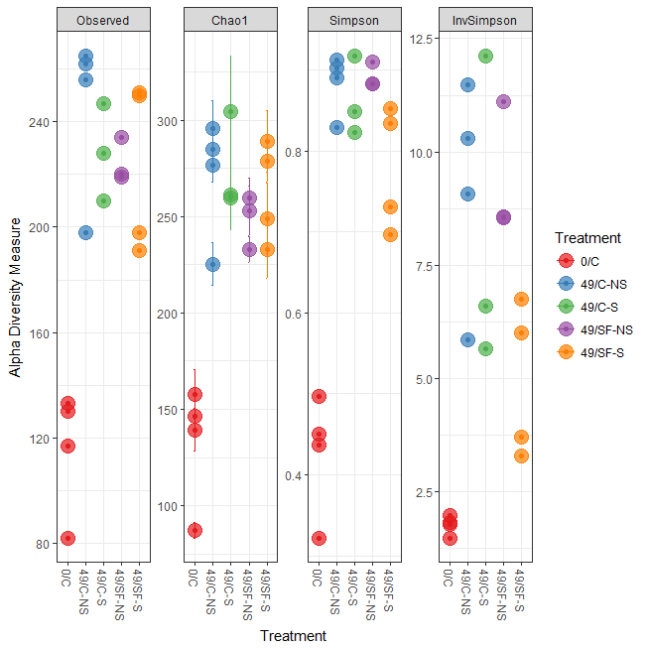

|  |  |  |  |  |  |  |
| --- | --- | --- | --- | --- | --- | --- |
| sample | Observed | Chao1 | se.chao1 | Shannon | Simpson | InvSimpson |
| 712 | 117 | 139.2353 | 11.08353 | 1.297571 | 0.450819 | 1.820895 |
| 713 | 130 | 157.5556 | 12.85919 | 1.463116 | 0.496464 | 1.985956 |
| 714 | 82 | 87.07692 | 4.036001 | 0.890493 | 0.32152 | 1.473883 |
| 715 | 133 | 146.1538 | 7.993534 | 1.360377 | 0.436798 | 1.775562 |
| 717 | 265 | 284.6875 | 8.701851 | 3.017492 | 0.889664 | 9.063247 |
| 718 | 262 | 295.913 | 14.13159 | 3.255478 | 0.912876 | 11.47783 |
| 719 | 256 | 276.5227 | 8.366144 | 3.182291 | 0.902799 | 10.28792 |
| 720 | 198 | 225.3333 | 11.23023 | 2.631894 | 0.829097 | 5.851277 |
| 723 | 228 | 304.5556 | 28.89333 | 2.761533 | 0.848586 | 6.604407 |
| 724 | 247 | 259.5357 | 6.490675 | 3.181911 | 0.917502 | 12.12152 |
| 725 | 210 | 261.3333 | 18.10734 | 2.411283 | 0.822874 | 5.645713 |
| 737 | 234 | 259.8 | 10.37646 | 2.863383 | 0.883049 | 8.550596 |
| 738 | 220 | 253 | 12.92629 | 3.054427 | 0.909926 | 11.10203 |
| 739 | 219 | 232.7778 | 6.58797 | 2.923237 | 0.883287 | 8.568037 |
| 742 | 198 | 249.1071 | 18.38947 | 2.190484 | 0.69689 | 3.299134 |
| 743 | 191 | 233.0882 | 15.04468 | 2.240052 | 0.730922 | 3.716388 |
| 744 | 250 | 289.1364 | 15.96929 | 2.809432 | 0.833748 | 6.014952 |
| 745 | 251 | 278.8235 | 11.04258 | 2.833406 | 0.851751 | 6.745395 |





|  |  |  |  |  |  |  |  |  |  |  |  |  |  |
| --- | --- | --- | --- | --- | --- | --- | --- | --- | --- | --- | --- | --- | --- |
| OUT | baseMean | log2FoldChange | lfcSE | stat | pvalue | padj | Kingdom | Phylum | Class | Order | Family | Genus | Species |
| 949863 | 150.1965 | 9.50982 | 1.16286 | 8.17796 | 2.89E-16 | 1.11E-14 | Bacteria | Firmicutes | Bacilli | Lactobacillales | NA | NA | NA |
| 102222 | 7.890611 | 5.787319 | 1.155621 | 5.007975 | 5.50E-07 | 4.22E-06 | Bacteria | Firmicutes | Bacilli | Lactobacillales | Lactobacillaceae | Pediococcus | NA |
| 1110317 | 1228.127 | 10.70916 | 0.974268 | 10.99201 | 4.18E-28 | 6.41E-26 | Bacteria | Firmicutes | Bacilli | Lactobacillales | Lactobacillaceae | Lactobacillus | brevis |
| 1991307 | 12.07279 | 6.644328 | 1.17445 | 5.657397 | 1.54E-08 | 1.31E-07 | Bacteria | Firmicutes | Bacilli | Lactobacillales | Lactobacillaceae | Lactobacillus | NA |
| 536754 | 10.65262 | 6.537177 | 1.138586 | 5.741488 | 9.38E-09 | 8.23E-08 | Bacteria | Firmicutes | Bacilli | Lactobacillales | Lactobacillaceae | Lactobacillus | brevis |
| 588197 | 13.57024 | 6.916812 | 1.190477 | 5.810121 | 6.24E-09 | 5.64E-08 | Bacteria | Firmicutes | Bacilli | Lactobacillales | Lactobacillaceae | Lactobacillus | brevis |
| New.CleanUp.ReferenceOTU174 | 33.83708 | 8.366116 | 1.157903 | 7.225228 | 5.00E-13 | 9.86E-12 | Bacteria | Firmicutes | Bacilli | Lactobacillales | Lactobacillaceae | Lactobacillus | NA |
| 3851582 | 4.383768 | 5.149642 | 1.380693 | 3.729752 | 0.000192 | 0.000764 | Bacteria | Firmicutes | Bacilli | Lactobacillales | Lactobacillaceae | Lactobacillus | NA |
| 4358821 | 7.958617 | 5.731407 | 1.242071 | 4.614396 | 3.94E-06 | 2.42E-05 | Bacteria | Firmicutes | Bacilli | Lactobacillales | Lactobacillaceae | Lactobacillus | NA |
| 604966 | 3794.383 | 12.33095 | 0.810014 | 15.22314 | 2.48E-52 | 7.62E-50 | Bacteria | Firmicutes | Bacilli | Lactobacillales | Lactobacillaceae | Lactobacillus | NA |
| New.CleanUp.ReferenceOTU2625 | 2.716164 | 3.798799 | 1.288706 | 2.947763 | 0.003201 | 0.00954 | Bacteria | Firmicutes | Bacilli | Lactobacillales | Lactobacillaceae | Lactobacillus | NA |
| New.CleanUp.ReferenceOTU8260 | 5.947351 | 5.122779 | 1.270187 | 4.033089 | 5.50E-05 | 0.000268 | Bacteria | Firmicutes | Bacilli | Lactobacillales | Lactobacillaceae | Lactobacillus | NA |
| New.CleanUp.ReferenceOTU15873 | 4.912754 | 3.993569 | 1.240848 | 3.21842 | 0.001289 | 0.004122 | Bacteria | Firmicutes | Bacilli | Lactobacillales | Leuconostocaceae | Weissella | NA |
| New.CleanUp.ReferenceOTU7086 | 2.214639 | 4.80792 | 1.267182 | 3.794182 | 0.000148 | 0.000615 | Bacteria | Firmicutes | Bacilli | Lactobacillales | Leuconostocaceae | NA | NA |
| 919796 | 6.049969 | 5.626132 | 1.583136 | 3.55379 | 0.00038 | 0.001405 | Bacteria | Firmicutes | Bacilli | Lactobacillales | Leuconostocaceae | Weissella | NA |
| 339358 | 165.2841 | 1.525047 | 0.386615 | 3.944616 | 7.99E-05 | 0.000361 | Bacteria | Firmicutes | Bacilli | Lactobacillales | Leuconostocaceae | NA | NA |
| 352468 | 37.57782 | 8.118109 | 1.206781 | 6.727078 | 1.73E-11 | 2.21E-10 | Bacteria | Firmicutes | Bacilli | Lactobacillales | Leuconostocaceae | Weissella | NA |
| 663969 | 1.741996 | 4.404647 | 1.347678 | 3.268324 | 0.001082 | 0.003533 | Bacteria | Firmicutes | Bacilli | Lactobacillales | Leuconostocaceae | NA | NA |
| New.CleanUp.ReferenceOTU7123 | 11.88367 | 2.527381 | 0.703682 | 3.591654 | 0.000329 | 0.001245 | Bacteria | Firmicutes | Bacilli | Lactobacillales | Leuconostocaceae | NA | NA |
| 564704 | 5.859891 | 3.414457 | 0.814039 | 4.194464 | 2.74E-05 | 0.000145 | Bacteria | Firmicutes | Bacilli | Lactobacillales | Leuconostocaceae | NA | NA |
| New.CleanUp.ReferenceOTU16960 | 26.88789 | 8.093583 | 1.114215 | 7.263933 | 3.76E-13 | 8.25E-12 | Bacteria | Firmicutes | Bacilli | Lactobacillales | Leuconostocaceae | NA | NA |
| New.CleanUp.ReferenceOTU6961 | 11.09084 | 2.864589 | 0.736118 | 3.891483 | 9.96E-05 | 0.000431 | Bacteria | Firmicutes | Bacilli | Lactobacillales | Leuconostocaceae | Leuconostoc | NA |
| New.CleanUp.ReferenceOTU4295 | 17.54381 | 4.573563 | 1.125588 | 4.063265 | 4.84E-05 | 0.000244 | Bacteria | Firmicutes | Bacilli | Lactobacillales | Leuconostocaceae | Leuconostoc | NA |
| 763362 | 113.1082 | 3.560391 | 0.412667 | 8.627764 | 6.26E-18 | 3.20E-16 | Bacteria | Firmicutes | Bacilli | Lactobacillales | Leuconostocaceae | Leuconostoc | NA |
| 254021 | 9.695139 | 3.24089 | 0.80901 | 4.005993 | 6.18E-05 | 0.000296 | Bacteria | Firmicutes | Bacilli | Lactobacillales | Leuconostocaceae | Leuconostoc | NA |
| 766563 | 32.38742 | 2.792681 | 0.476203 | 5.864472 | 4.51E-09 | 4.19E-08 | Bacteria | Firmicutes | Bacilli | Lactobacillales | Leuconostocaceae | Leuconostoc | NA |
| 540940 | 1048.263 | 2.830268 | 0.300153 | 9.429408 | 4.12E-21 | 2.53E-19 | Bacteria | Firmicutes | Bacilli | Lactobacillales | Leuconostocaceae | Leuconostoc | NA |
| New.CleanUp.ReferenceOTU2432 | 2.275308 | 4.578181 | 1.50139 | 3.049296 | 0.002294 | 0.006904 | Bacteria | Firmicutes | Bacilli | Lactobacillales | Leuconostocaceae | Leuconostoc | NA |
| New.CleanUp.ReferenceOTU3972 | 54.01341 | 7.553862 | 1.083277 | 6.973156 | 3.10E-12 | 4.89E-11 | Bacteria | Firmicutes | Bacilli | Lactobacillales | Leuconostocaceae | Leuconostoc | NA |
| New.CleanUp.ReferenceOTU7505 | 4.000586 | 3.843343 | 1.221391 | 3.146694 | 0.001651 | 0.005121 | Bacteria | Firmicutes | Bacilli | Lactobacillales | Lactobacillaceae | Lactobacillus | NA |
| 565537 | 27.44628 | 6.883964 | 1.145217 | 6.011057 | 1.84E-09 | 1.77E-08 | Bacteria | Firmicutes | Bacilli | Lactobacillales | Lactobacillaceae | NA | NA |
| New.CleanUp.ReferenceOTU236 | 35.06172 | 7.795034 | 1.091871 | 7.139153 | 9.39E-13 | 1.70E-11 | Bacteria | Firmicutes | Bacilli | Lactobacillales | Lactobacillaceae | Lactobacillus | NA |
| New.CleanUp.ReferenceOTU14457 | 70.7466 | 6.726499 | 1.056899 | 6.364371 | 1.96E-10 | 2.01E-09 | Bacteria | Firmicutes | Bacilli | Lactobacillales | Lactobacillaceae | NA | NA |
| New.CleanUp.ReferenceOTU15202 | 6.267329 | 4.154518 | 1.251314 | 3.320125 | 0.0009 | 0.002978 | Bacteria | Firmicutes | Bacilli | Lactobacillales | Streptococcaceae | Lactococcus | NA |
| 4482944 | 9.078544 | 4.798393 | 1.33289 | 3.599992 | 0.000318 | 0.001221 | Bacteria | Firmicutes | Bacilli | Lactobacillales | Leuconostocaceae | Leuconostoc | NA |
| New.CleanUp.ReferenceOTU2503 | 6.262078 | 2.783103 | 0.834165 | 3.336393 | 0.000849 | 0.002863 | Bacteria | Proteobacteria | Alphaproteobacteria | Rickettsiales | mitochondria | NA | NA |
| 1918929 | 422.6867 | -4.06755 | 0.421396 | -9.65255 | 4.79E-22 | 3.68E-20 | Bacteria | Proteobacteria | Alphaproteobacteria | Rickettsiales | mitochondria | NA | NA |
| New.CleanUp.ReferenceOTU16348 | 46.56244 | -3.71084 | 0.566007 | -6.55617 | 5.52E-11 | 6.05E-10 | Bacteria | Proteobacteria | Alphaproteobacteria | Rickettsiales | mitochondria | NA | NA |
| New.CleanUp.ReferenceOTU5299 | 5.804558 | -6.72109 | 1.339735 | -5.01673 | 5.26E-07 | 4.14E-06 | Bacteria | Proteobacteria | Alphaproteobacteria | Rickettsiales | mitochondria | NA | NA |
| New.CleanUp.ReferenceOTU6757 | 4.981724 | -4.58804 | 0.952708 | -4.81579 | 1.47E-06 | 9.79E-06 | Bacteria | Proteobacteria | Alphaproteobacteria | Rickettsiales | mitochondria | NA | NA |
| New.CleanUp.ReferenceOTU13241 | 3.206422 | 3.866177 | 1.314915 | 2.940248 | 0.003279 | 0.009681 | NA | NA | NA | NA | NA | NA | NA |
| New.CleanUp.ReferenceOTU11779 | 19.6857 | 4.388984 | 1.109245 | 3.95673 | 7.60E-05 | 0.000348 | Bacteria | Proteobacteria | Gammaproteobacteria | Enterobacteriales | Enterobacteriaceae | Serratia | NA |
| New.CleanUp.ReferenceOTU12866 | 12.28358 | 4.844662 | 1.306148 | 3.709122 | 0.000208 | 0.000819 | Bacteria | Proteobacteria | Gammaproteobacteria | Enterobacteriales | Enterobacteriaceae | NA | NA |
| New.CleanUp.ReferenceOTU10145 | 2.56607 | -6.11703 | 1.338008 | -4.57174 | 4.84E-06 | 2.86E-05 | NA | NA | NA | NA | NA | NA | NA |
| New.CleanUp.ReferenceOTU14445 | 2.854339 | -5.90802 | 1.87232 | -3.15545 | 0.001602 | 0.00502 | Bacteria | Proteobacteria | Gammaproteobacteria | Enterobacteriales | Enterobacteriaceae | NA | NA |
| New.CleanUp.ReferenceOTU8543 | 2.986955 | -5.70343 | 1.437011 | -3.96895 | 7.22E-05 | 0.000336 | Bacteria | Proteobacteria | Gammaproteobacteria | Enterobacteriales | Enterobacteriaceae | Erwinia | NA |
| New.CleanUp.ReferenceOTU413 | 1.848165 | -4.22345 | 1.358034 | -3.10998 | 0.001871 | 0.005687 | Bacteria | Proteobacteria | Gammaproteobacteria | Enterobacteriales | Enterobacteriaceae | NA | NA |
| New.CleanUp.ReferenceOTU13388 | 7.37506 | 4.415601 | 1.26576 | 3.488498 | 0.000486 | 0.001759 | Bacteria | Firmicutes | Bacilli | Lactobacillales | Lactobacillaceae | NA | NA |
| 1096738 | 4.586098 | -21.5088 | 4.450169 | -4.83326 | 1.34E-06 | 9.16E-06 | Bacteria | Proteobacteria | Gammaproteobacteria | Pseudomonadales | Moraxellaceae | NA | NA |
| 814176 | 165.8921 | -9.03292 | 1.909946 | -4.72941 | 2.25E-06 | 1.44E-05 | Bacteria | Proteobacteria | Betaproteobacteria | Burkholderiales | Burkholderiaceae | Burkholderia | NA |
| 1111294 | 15.45651 | -3.08618 | 0.653873 | -4.71985 | 2.36E-06 | 1.48E-05 | Bacteria | Proteobacteria | Gammaproteobacteria | Enterobacteriales | Enterobacteriaceae | NA | NA |
| 372473 | 29.38743 | -4.67859 | 1.409478 | -3.31938 | 0.000902 | 0.002978 | Bacteria | Proteobacteria | Gammaproteobacteria | Enterobacteriales | Enterobacteriaceae | NA | NA |
| 778478 | 7.317316 | -5.4295 | 1.052807 | -5.15716 | 2.51E-07 | 2.03E-06 | Bacteria | Proteobacteria | Gammaproteobacteria | Enterobacteriales | Enterobacteriaceae | NA | NA |
| New.CleanUp.ReferenceOTU311 | 11.43721 | -5.11359 | 0.754026 | -6.78172 | 1.19E-11 | 1.66E-10 | Bacteria | Proteobacteria | Gammaproteobacteria | Enterobacteriales | Enterobacteriaceae | NA | NA |
| 552376 | 14.67371 | -4.92269 | 0.681662 | -7.22159 | 5.14E-13 | 9.86E-12 | Bacteria | Proteobacteria | Gammaproteobacteria | Enterobacteriales | Enterobacteriaceae | NA | NA |
| 813217 | 13.51697 | -2.3677 | 0.68656 | -3.44865 | 0.000563 | 0.002011 | Bacteria | Proteobacteria | Gammaproteobacteria | Enterobacteriales | Enterobacteriaceae | NA | NA |
| 810831 | 10.90837 | -2.52316 | 0.732329 | -3.44539 | 0.00057 | 0.002012 | Bacteria | Proteobacteria | Gammaproteobacteria | Enterobacteriales | Enterobacteriaceae | NA | NA |
| 275097 | 3.992561 | -4.06032 | 0.915279 | -4.43615 | 9.16E-06 | 5.30E-05 | Bacteria | Proteobacteria | Gammaproteobacteria | Enterobacteriales | Enterobacteriaceae | Serratia | NA |
| New.CleanUp.ReferenceOTU13901 | 18.8833 | 3.06912 | 0.946583 | 3.242316 | 0.001186 | 0.003831 | Bacteria | Proteobacteria | Gammaproteobacteria | Enterobacteriales | Enterobacteriaceae | Serratia | marcescens |
| New.CleanUp.ReferenceOTU561 | 1.977858 | -4.8842 | 1.291048 | -3.78313 | 0.000155 | 0.000634 | NA | NA | NA | NA | NA | NA | NA |
| New.CleanUp.ReferenceOTU7445 | 7.225932 | 2.988287 | 0.838174 | 3.565234 | 0.000364 | 0.001361 | Bacteria | Cyanobacteria | Chloroplast | Streptophyta | NA | NA | NA |
| 616310 | 5468.764 | -3.39743 | 0.450229 | -7.54599 | 4.49E-14 | 1.25E-12 | Bacteria | Cyanobacteria | Chloroplast | Streptophyta | NA | NA | NA |
| 153978 | 180.942 | -3.01829 | 0.464789 | -6.49391 | 8.36E-11 | 8.85E-10 | Bacteria | Cyanobacteria | Chloroplast | Streptophyta | NA | NA | NA |
| New.CleanUp.ReferenceOTU10672 | 6.649759 | 2.672326 | 0.783912 | 3.408959 | 0.000652 | 0.002275 | Bacteria | Cyanobacteria | Chloroplast | Streptophyta | NA | NA | NA |
| 1084865 | 7.017787 | -7.76554 | 1.280301 | -6.0654 | 1.32E-09 | 1.30E-08 | Bacteria | Firmicutes | Bacilli | Bacillales | Staphylococcaceae | Staphylococcus | sciuri |
| New.CleanUp.ReferenceOTU1435 | 4.580416 | 4.442817 | 1.417072 | 3.135208 | 0.001717 | 0.005272 | Bacteria | Firmicutes | Bacilli | Lactobacillales | Lactobacillaceae | Lactobacillus | NA |
| New.CleanUp.ReferenceOTU15878 | 5.464746 | 5.006638 | 1.168831 | 4.283458 | 1.84E-05 | 0.000103 | Bacteria | Firmicutes | Bacilli | Lactobacillales | Lactobacillaceae | NA | NA |
| New.CleanUp.ReferenceOTU6321 | 24.13805 | 7.286873 | 1.102424 | 6.609864 | 3.85E-11 | 4.37E-10 | Bacteria | Firmicutes | Bacilli | Lactobacillales | Lactobacillaceae | Lactobacillus | NA |
| 586387 | 7.717332 | 3.543955 | 0.906188 | 3.910839 | 9.20E-05 | 0.000409 | Bacteria | Firmicutes | Bacilli | Lactobacillales | Streptococcaceae | Lactococcus | NA |
| 697063 | 15.31717 | 2.632522 | 0.620687 | 4.241304 | 2.22E-05 | 0.000122 | Bacteria | Firmicutes | Bacilli | Lactobacillales | Streptococcaceae | Lactococcus | NA |
| 716006 | 403.654 | 3.305639 | 0.43411 | 7.614748 | 2.64E-14 | 8.11E-13 | Bacteria | Firmicutes | Bacilli | Lactobacillales | Streptococcaceae | Lactococcus | NA |
| New.CleanUp.ReferenceOTU2026 | 9.906609 | 4.849584 | 1.177012 | 4.120249 | 3.78E-05 | 0.000197 | Bacteria | Firmicutes | Bacilli | Lactobacillales | Streptococcaceae | Lactococcus | NA |
| New.CleanUp.ReferenceOTU6313 | 13.21775 | 5.39896 | 1.108445 | 4.870751 | 1.11E-06 | 7.94E-06 | Bacteria | Firmicutes | Bacilli | Lactobacillales | Streptococcaceae | Lactococcus | NA |
| 637409 | 29.88875 | 5.942797 | 0.898339 | 6.615313 | 3.71E-11 | 4.37E-10 | Bacteria | Firmicutes | Bacilli | Lactobacillales | Streptococcaceae | Lactococcus | NA |
| New.CleanUp.ReferenceOTU13669 | 35.23933 | 8.191985 | 1.089062 | 7.522057 | 5.39E-14 | 1.27E-12 | Bacteria | Firmicutes | Bacilli | Lactobacillales | Streptococcaceae | Lactococcus | NA |
| New.CleanUp.ReferenceOTU247 | 5.532175 | 4.164591 | 1.246341 | 3.341453 | 0.000833 | 0.002843 | Bacteria | Firmicutes | Bacilli | Lactobacillales | Lactobacillaceae | Lactobacillus | NA |
| New.CleanUp.ReferenceOTU12183 | 56.38759 | 6.972702 | 1.052122 | 6.627276 | 3.42E-11 | 4.20E-10 | Bacteria | Firmicutes | Bacilli | Lactobacillales | Lactobacillaceae | NA | NA |
| New.CleanUp.ReferenceOTU16754 | 31.64554 | 7.958131 | 1.180239 | 6.742815 | 1.55E-11 | 2.07E-10 | Bacteria | Firmicutes | Bacilli | Lactobacillales | Lactobacillaceae | Lactobacillus | NA |
| New.CleanUp.ReferenceOTU2112 | 9.109829 | 4.136145 | 1.119889 | 3.693352 | 0.000221 | 0.00086 | Bacteria | Firmicutes | Bacilli | Lactobacillales | Leuconostocaceae | Leuconostoc | NA |
| New.CleanUp.ReferenceOTU13955 | 83.77185 | 9.14643 | 1.108885 | 8.248311 | 1.61E-16 | 7.05E-15 | Bacteria | Firmicutes | Bacilli | Lactobacillales | NA | NA | NA |
| New.CleanUp.ReferenceOTU6607 | 11.37224 | 4.146942 | 1.22295 | 3.390935 | 0.000697 | 0.002403 | Bacteria | Firmicutes | Bacilli | Lactobacillales | NA | NA | NA |
| New.CleanUp.ReferenceOTU3735 | 3.463482 | 5.406194 | 1.320632 | 4.093641 | 4.25E-05 | 0.000217 | Bacteria | Firmicutes | Bacilli | Lactobacillales | Lactobacillaceae | Lactobacillus | NA |
| New.CleanUp.ReferenceOTU13919 | 10.84743 | 5.615627 | 1.134501 | 4.949864 | 7.43E-07 | 5.56E-06 | Bacteria | Proteobacteria | Gammaproteobacteria | Enterobacteriales | Enterobacteriaceae | NA | NA |
| New.CleanUp.ReferenceOTU4865 | 14.01906 | 4.408406 | 1.091425 | 4.039128 | 5.37E-05 | 0.000266 | Bacteria | Firmicutes | Bacilli | Lactobacillales | Lactobacillaceae | NA | NA |
| New.CleanUp.ReferenceOTU10163 | 5.112869 | 5.413576 | 1.278434 | 4.234539 | 2.29E-05 | 0.000123 | Bacteria | Firmicutes | Bacilli | Lactobacillales | Lactobacillaceae | Lactobacillus | NA |
| New.CleanUp.ReferenceOTU4016 | 4.343042 | 4.895562 | 1.253449 | 3.905673 | 9.40E-05 | 0.000412 | Bacteria | Firmicutes | Bacilli | Lactobacillales | Lactobacillaceae | Lactobacillus | NA |
| New.CleanUp.ReferenceOTU14935 | 6.404349 | 6.065342 | 1.261901 | 4.806513 | 1.54E-06 | 1.00E-05 | Bacteria | Firmicutes | Bacilli | Lactobacillales | Lactobacillaceae | Lactobacillus | NA |
| New.CleanUp.ReferenceOTU1078 | 20.16607 | 6.196427 | 1.105466 | 5.605262 | 2.08E-08 | 1.73E-07 | Bacteria | Firmicutes | Bacilli | Lactobacillales | Lactobacillaceae | NA | NA |
| New.CleanUp.ReferenceOTU13508 | 2.982958 | 4.703685 | 1.239529 | 3.794734 | 0.000148 | 0.000615 | Bacteria | Firmicutes | Bacilli | Lactobacillales | Lactobacillaceae | Lactobacillus | NA |
| New.CleanUp.ReferenceOTU11068 | 18.17398 | 7.816023 | 1.121498 | 6.969272 | 3.19E-12 | 4.89E-11 | Bacteria | Firmicutes | Bacilli | Lactobacillales | Lactobacillaceae | Lactobacillus | brevis |
| 692823 | 9.187234 | 5.65746 | 1.233187 | 4.587676 | 4.48E-06 | 2.70E-05 | Bacteria | Firmicutes | Bacilli | Lactobacillales | NA | NA | NA |
| New.CleanUp.ReferenceOTU17246 | 6.813415 | 4.928111 | 1.116742 | 4.412935 | 1.02E-05 | 5.80E-05 | Bacteria | Firmicutes | Bacilli | Lactobacillales | NA | NA | NA |
| New.CleanUp.ReferenceOTU2550 | 3.889998 | 4.685744 | 1.343448 | 3.487849 | 0.000487 | 0.001759 | NA | NA | NA | NA | NA | NA | NA |
| New.CleanUp.ReferenceOTU16105 | 5.207643 | 5.709578 | 1.172088 | 4.871287 | 1.11E-06 | 7.94E-06 | Bacteria | Firmicutes | Bacilli | Lactobacillales | Lactobacillaceae | Lactobacillus | NA |
| 160548 | 107.2221 | 7.578867 | 1.077985 | 7.030588 | 2.06E-12 | 3.51E-11 | Bacteria | Firmicutes | Bacilli | Lactobacillales | Lactobacillaceae | Lactobacillus | NA |
| 4429559 | 12.24408 | 3.744663 | 1.179338 | 3.175225 | 0.001497 | 0.004739 | Bacteria | Firmicutes | Bacilli | Lactobacillales | Lactobacillaceae | Lactobacillus | brevis |
| 613189 | 317.8578 | 8.412903 | 1.09849 | 7.658605 | 1.88E-14 | 6.41E-13 | Bacteria | Firmicutes | Bacilli | Lactobacillales | Lactobacillaceae | NA | NA |
| 192776 | 19.32626 | 5.249242 | 1.085872 | 4.834124 | 1.34E-06 | 9.16E-06 | Bacteria | Firmicutes | Bacilli | Lactobacillales | Lactobacillaceae | NA | NA |
| 781576 | 203.0933 | 7.982117 | 1.059378 | 7.534724 | 4.89E-14 | 1.25E-12 | Bacteria | Firmicutes | Bacilli | Lactobacillales | Lactobacillaceae | NA | NA |
| New.CleanUp.ReferenceOTU17719 | 7.934852 | 4.383506 | 1.17104 | 3.743259 | 0.000182 | 0.000734 | Bacteria | Firmicutes | Bacilli | Lactobacillales | Lactobacillaceae | NA | NA |
| 760901 | 2156.558 | 11.19298 | 1.07797 | 10.38339 | 2.95E-25 | 3.02E-23 | Bacteria | Firmicutes | Bacilli | Lactobacillales | Lactobacillaceae | NA | NA |
| New.CleanUp.ReferenceOTU2086 | 49.37805 | 4.444286 | 1.152284 | 3.856938 | 0.000115 | 0.00049 | Bacteria | Firmicutes | Bacilli | Lactobacillales | Lactobacillaceae | Lactobacillus | NA |
| 335887 | 18.86299 | 4.806963 | 1.210273 | 3.971802 | 7.13E-05 | 0.000336 | Bacteria | Firmicutes | Bacilli | Lactobacillales | Lactobacillaceae | Lactobacillus | NA |
| 354494 | 311.5149 | 8.222742 | 1.184652 | 6.94106 | 3.89E-12 | 5.69E-11 | Bacteria | Firmicutes | Bacilli | Lactobacillales | Lactobacillaceae | Lactobacillus | NA |